University of Warsaw Faculty of Economic Sciences

Mykyta Sikriier

Album N°: 381815

Commercial Banking Front Office: new approach to serve customers

Master degree thesis

Field of study: Quantitative Finance

The thesis written under the supervision of

PhD Krzysztof Spirzewski Finance and Accounting

WNE UW

Warsaw, September 2021

*Declaration of the supervisor*

I declare that the following thesis was written under my supervision and I state that it meets all criteria to be submitted for the procedure of academic degree award.

Date Signature of the Supervisor

*Declaration of the author of the thesis*

Aware of the legal responsibility, I declare that I am the sole author of the following thesis and that the thesis is free from any content that constitutes copyright infringement or has been acquired contrary to applicable laws and regulations.

I also declare that the thesis has never been a subject of degree-awarding procedures in any higher education institution.

Moreover I declare that the attached version of the thesis is identical with the enclosed electronic version.

Date Signature of the Author

## Summary

In 2007 PSD had shown an interest of financial regulators in banking competitiveness by digital instruments. Later, PSD2 triggered a new wave of banking digitalization, openness, Big Data usage and third-party integrations. This thesis seeks to analyze the ways of development of commercial banks Front Offices using ML & AI technologies. The research focuses on the importance of openness brought by PSD2 and Open Banking initiative. Study investigates ways of application of ML & AI technologies on various layers of a bank and targets the importance of usage of available customer data in order to achieve market efficiency. The research survey of customer satisfaction was conducted in order to determine current level of satisfaction with Front Office service.

## Streszczenie

Dyrektywa PSD z roku 2007 wskazała na duże zainteresowanie regulatorów rynku finansowego zwiększenia konkurencyjności sektora bankowego za pomocą instrumentów cyfrowych. Kolejna wersja tej Dyrektywy (znana pod nazwą PSD2) wywołała nową falę cyfryzacji banków kierując swe zmiany w stronę otwartości infrastruktury IT, wykorzystania Big Data i integracji z firmami zewnętrznymi. Niniejsza praca ma na celu zbadanie rozwoju działu Front Office w banku komercyjnym dokonywanego za pomocą technologii ML & AI. Badania koncentrują się wokół znaczenia otwartości, wniesionej przez PSD2 i inicjatywy Open Banking. Praca opisuje sposoby wykorzystania technologii ML & AI na różnych poziomach banku i ocenia znaczenie wykorzystania istniejących danych klientów w celu osiągnięcia efektywności rynkowej. Przeprowadzono badanie satysfakcji klienta w celu określenia poziomu zadowolenia z usług Front Office.

## Key words

banking, banking services, virtual banking, chat-bots

## Field of the thesis (codes according to the Erasmus program)

Economics (14300)

## Thematic classification

**The title of the thesis in Polish**

Front Office Banków Komercyjnych: nowe podejście do obsługi klientów

**TABLE OF CONTENTS**

# INTRODUCTION . . . . . . . . . . . . . . . . . . . . . . . . . . . . . . . . . . . . . 5

CHAPTER I. Banking system overview **. . . . . . . . . . . . . . . . . . . . . . . . .** 6

1.1. Historical overview . . . . . . . . . . . . . . . . . . . . . . . . . . . . . . . . . . 6

1.1.1. Operating model of commercial bank . . . . . . . . . . . . . . . . . . . . . . 7 1.2. Digital banking 10

* 1. Open Banking Movement and PSD2 13
     1. Overview of PSD2 13
     2. Open Banking 17

CHAPTER II. Artificial Intelligence and Conversational Banking 23

* 1. Artificial Intelligence in Operational bank activity 23
     1. Artificial Intelligence in Investment Banking 24
     2. Artificial Intelligence in Commercial Banking 24
     3. AI in Back office 26
     4. AI in Middle office 27
     5. AI in Front office 29
  2. Conversational banking 33
     1. Hybrid approach 39

CHAPTER III. Chat-bots as a new approach 43

* 1. Chat-bots. Overview and theoretical aspect 43
     1. Structure 49
     2. Frontend 49
     3. Middleware 50
     4. Backend 51
     5. Conclusion 52
  2. Strategy of a chat-bot solution 52
     1. Open Banking API development and extension 53
     2. Rule-based middleware 55
     3. Middleware with Machine Learning 56
     4. Recommendations and notifications 57
     5. Summary of approaches 57
  3. Satisfaction with current state of front-office 61

CONCLUSIONS 68

BIBLIOGRAPHY 70

LIST OF APPENDICES 76

# INTRODUCTION

Nowadays, it is practically impossible to imagine life without online banking. Online banking is extremely comfortable for the clients because of its simplicity and speed of provided services. It is pretty obvious, that banks are striving to develop this field. The main priority is the comfort of a client, leading to development of Big Data as a main branch of improvements. Based on Gartner, around 34% of banks were investing into Big Data technologies.

Banks are storing everything — profiles, transactions and customer history, internal in- formation. Repositories are literally inflated to petabytes of data. Artificial Intelligence in a connection with Machine Learning allows software to study client behavior and make deci- sions autonomously.

However, in any case, at least for now, there should be a manager, who would follow and approve decisions that were made programmatically. Both Artificial Intelligence and Machine Learning have been being used for a long time, but it is reaching its peak with Big Data, with which it allows processing huge amounts of information quickly and efficiently. Consequently, it is critically important for the banking industry to rely on and collect more information about each client.

The aim of the thesis is to research current state of industry, regulations and technology in order to examine requirements for a Chat-bot solution with Artificial Intelligence in a Com- mercial Banking Front Office and usefulness of such solution in a current market state.

The main hypothesis is: Commercial Banking clients are ready for Automated Front Of- fices in a form of Chat-bot. To proof this thesis the descriptive method and survey will be used. The main literature used are scientific papers that verify functionality of commercial bank-

ing. The fundamental papers of this work were ”AI in banking: the reality behind the hype” written by Laura Noonan, ”Artificial Intelligence and The Banking Industry’s $1 Trillion Op- portunity” written by Lisa Joyce and ”AI Could Destroy Traditional Banking As We Know It” written by Jim Marous. Those articles focus on occurring changes of banking by AI and its importance in near future.

Extremely important for this thesis were researches ”Redefine Banking with Artificial Intelligence”, ”Chatbots are here to stay” and ”Ready for Conversational Banking?” by Accen- ture. Both of those define main concepts of Conversational Banking and major role of chatbots backed by AI in banking evolution

Among the books the most noteworthy is ”Bank 4.0. Banking Everywhere, Never at a Bank” written by Brett King. This book is about future of banking. Author farsees fundamental banking paradigm shift from products to delivery services in conjunction with AI and other smart technologies.

Chapter I is devoted to an overview of current banking system and influence of digital banking over it. Additionally, mentioned chapter I contains analysis of various movements of banking towards openness, Open Banking and PSD2.

In chapter II is an overview of current application of Artificial Intelligence and Conversa- tional Banking paradigm.

Chapter III concentrates over noval practical application of an AI in a Front-office in a form of a chat-bot. In addition, chapter III proposes a strategy for a chat-bot solution develop- ment and integration in existing bank system.

Finally, results of econometric study are presented. Study shows respondents’ satisfaction with existing front-office and their preparation towards chat-bot as an interlocutor.

The last section consists of thesis conclusions.

# CHAPTER I

## Banking system overview

* 1. **Historical overview**

In modern banking systems there are two types of banking institutions — central banks and commercial banks. The activity of Central Bank of any country aims to solve next three tasks: ensuring stability and purchasing power of the national currency, stability and liquidity of the banking system, efficiency and reliability of the payment system. At the same time, Central Bank operate as an intermediary between the state and commercial banks, and, respectively, rest of the economy through commercial banks. In modern conditions, the Central Bank, usually, performs following functions:

* + - Exclusive right of money issuing
    - ”Bank of banks”
    - Bank of government
    - Regulation of the monetary system
    - Implementation of monetary policy
    - Organization of payment, clearing and settlement relations
    - Main state settlement centre

Obviously, this list of functions can be changed, by adding or removing certain functions for different countries, as every country has its own view on banking system, based on cultural, historical and religious conditions, but as we focus on European and/or United States banking systems, we may stick to this list. Commercial bank, in its turn, is a bank, which specializes on provision of services for corporate and individual customers. Commercial banks by type can be universal and specialized. Universal banks carry out all or almost all types of banking operations: provide both short-term and long-term loans, accept deposits of all types, perform investing operations and consultations, and provide all sorts of financial services to its customers. On the contrary, specialized banks usually offer one or several types of banking operations. In some countries, banking legislation prevents or simply prohibits a wide range of transactions. As example of such prohibition, we can refer to famous “Banking Act of 1933”, which forbid commercial banks to make investment operations until it was repealed in 1999.

As for Europe, situation was more interesting. Firstly, European banking leaders were United Kingdom, France and Germany. Glass-Steagall Act had some influence in Europe and started discussions about role of universal banking and possibility of functional division of banks. Nevertheless, general depression and major political changes did not lead to such kind of laws, due to the increasing influence of government as well as rise of authoritarianism. En- glish banks observed increasing governmental control, while German banks became a gear of national-socialist machine. For France, situation was different, but equity markets were not as developed, so there were no movement towards investment control. As example of similar act, we can observe Belgium, which carried out a banking reform in 1934, which separated deposit banks and holding companies.

Development of European banking system and repeal of Banking Act of 1933 in the United States in 1999 allowed us to observe next types of banks, by its functions:

* + - Commercial banks
    - Investment banks
    - Universal banks

As it was mentioned before, these days customers expect from commercial banks to have various utility and agency services, not just basic functionality of accepting deposits and pro- viding loans. Escalation of competition in the global financial market, technological changes and ever-increasing variety of customer needs have had and are expected to continue to have an impact on banking management. The current stage in the development of the banking services market is characterized by the introduction of new banking services for both individuals and legal entities, an increase in the volume of banking services and an increase in the importance of IT technologies in this sector. What even more important, is the fact, that the banks themselves are interested in providing that sort of services. This is due to the fact, that financial crisis of 2007-2008 showed to banks how it is important to have stable source of income. These sec- ondary functions allow banks to charge customers for their services, allowing to bank to lower operational risk. Importance of secondary functions is growing due to the necessity of more efficient management of working capital, risk management and liquidity. In such case, focus on a client involvment for commercial banks became a favourable solution.

## Operating model of commercial bank

By functionality, it is possible to divide commercial bank into two major division:

* + - * Banking operations
      * Internal operations

Banking operations division is responsible for actual financial operations. Functionally it can be divided to:

* + - * Economic management
      * Deposit management
      * Settlement management
      * Credit management
      * Securities management
      * Foreign exchange department
      * Operational management
      * Cash operations department

Internal operations is a supportive division which guarantees proper functionallity of a main financial operations division. Functionally, it can be divided to:

* + - * Organization department
      * Human resources department
      * Social economic department
      * Internal accounting department
      * Control and audit department
      * Information technologies department

Nevertheless, banking operations division can be divided not only by functionallity, but also by its customer publicity. Historically, internally by publicity commercial banks were di- vided by exterior departments — front office — which is responsible for client communication and is a vanguard of a bank, and interior departments — back office — which is generally re- sponsible for operations execution and is a rearguard of a bank. With natural growth commercial banks required additional functionality, a layer which would handle various analytical work and would be a middleware between front office and back office — middle office.

Publicity layers:

* + - * Front office
      * Middle office
      * Back office

Table 1. Structure of human interaction on banking layers

Clients

Employees

Front office

*Source:* Own study

Middle office

Back office

Front office — operational division of a bank and its other structural units, responsible for management and development of relationships with counteragents. In front office occurs direct communication with clients, primary verification of loaners’ data, collection analysis of received documents, preparation of contracts with clients and other interoperations with counteragents. Front office as a term also describes external interfaces, as instruments and rules of interaction of the automated banking system with users and computer networks, in bank branches, in which occurs direct work with clients and the conclusion of contracts and transactions of primar bank- ing business. Front office employees are responsible for customer attraction, customer contact development and for a service to existing customers. As for card payment systems, front office includes servicing ATM network and POS terminals, interacting with payment card acceptance points and maintaining a network of self-service information devices. Front offices continu- ously interact with the analytical and processing centers of the system, middle office and back office. Typically, front office functions include client communication, receiving and input of further processing client documents, providing the client with information, calling and sending information messages to clients, processing incoming calls. As an example of real front of- fice units there are call centers, trading and showrooms, customer service cash decks. Among digital front office units there are customer self-service portals, personal accounts and inter- net banking, remote banking systems, front-office supporting information systems, like CRMs (Customer Relationship Management), ERPs (Enterprise Resource Management), CBSs (Core Banking Systems).

Middle office — bank division, which contains a set of business processes, procedures, normative documents (regulations), reference books, printed forms, organizational and staff doc- uments that ensure the preparation and execution of decision-making processes. Middle office units carry out verification and actual processing of client operations. Unlike the front office,

even though middle-office workers operations directly related to the client, as a rule, those do not have direct contact with clients. Canonical examples of a middle office unit is a risk man- agement unit and a credit scoring unit. As an information systems middle-office use position accounting system, borrower verification system, scoring calculation system, etc.

Back office — operational and accounting division of the bank, which guarantees the work of the divisions involved in the asset and liabilities management, carries out the execu- tion, accounting and registration of the transactions with securities, as well as settlements with customers.

The tasks of the Back Office are credit affairs formation and direct loan issuance pro- cessing, loan portfolio quality assessment, account opening, supporting accounting operations, documentation and transactions support concluded by traders of counterparty companies in the front office, etc. Depending on its structure, bback office may consist of one division or may have a couple of units, united by documentation procedures, risk management, accounting and calculations. However, certain banks may unite some functionaity with middle office, as an example — risk management, which usually is understood as middle office activity, as it struc- turally supports decision-making.

As a conclusion, back office is a division which carries out other divisions involved in asset and liabilities managment. Main back office task is the documentary and electronic regis- tration and maintenance of both market transactions and internal analytcial transactions between organizational units within the framework of the financial resource redistribution system. This is a support unit of the company which performs administrative functions to help customer service personnel carry out their duties.

## Digital banking

In general, Digital Banking is relatively new term and its definition is vaguely differed from virtual and online banking. The concept of Digital Banking is based on digitalization of banking services — making those available online. Currently, there are two major ways of definition — inclusive and exclusive. Inclusive definition requires for banking services to be digitalized and entirely available online. As a result, this definition requires for every single element to be digitalized. Exclusive way requires banking services to be available exceptionally in digital channels, as a contrast to traditional banking, which is by default is not digitalized at all. By uniting both definitions we can state, that digital banking is an ability to execute financial operations remotely with a usage of personal electronic devices due to development of bank’s

information technologies.

The most developed forms of digital banking are virtual banks, online banks and internet banking. Virtual bank is a bank, which is accessible primarly via digital channels. Basically, it is a bank, which is entirely placed in internet. In some cases it may have an office for customers, most likely for branding purposes or for complicated and conflict situations.

Nevertheless, there are the most radical banks, which exist exclusively in internet and provide services remotely. It is possible to confuse those with online banks, which are usually just banks using internet as a form of client communication. In its turn, internet banking is usually just an additional client interface as a form of a personal web app or mobile application for banking operations.

In the Digital Age of XXI Century, digitization of banking services is more of a business requirement in modern market and financial sector evolution, then some overhyped technology. Changes, that will be brought by digitization offer benefits for both financial institutuions and customers. Firstly, it brings efficiency, as it requires digitalization on a core level, which allows deriving from technology. Currently, banks assume being digital as a tool, and not a core banking feature. Secondly, it brings cost efficiency. There are reports, which estimate that banks can increase EBITDA margins by up to 40% on digital automation and removing middlewares.

Additionally, technology would allow to faster react on environmental changes on every level. Banks, being slow responding to nature by nature, do not need to be that conservative on every level of operation. As for front office, bank has to be agile to changes on a customer market. At the same time, bank has to be agile enough to react to regulatory changes as fast as it can. Furthemore, digital banking significantly changes levels and forms of competitiveness for customer base. For banks, it is much easier to increase customer engagement as it would be able to access various digital channels which customers are using. At the same time, it would be much harder to obtain new customers without providing active competition policy.

Obviously, this is extremelly positive from a customer perspective. As a whole, customer benefits are more obvious. Firstly, customers obtain more options, more choices, and are able to freely switch between them. This includes both banking products and banks themselves. Secondly, digital products are much easier to use. Customer should not come to a branch office for basic banking operations. Moreover, for younger tech generations it is especially important and usually an important argument on choosing bank to partner with. As a last point, due to higher competition for a customer, the last may achieve various cost advantages for increasing engagement, as for example, cashbacks or personally offered low loan rates.

Even though digital banking is considered relatively young, factically, it is a mature form

of retail banking. According to Deloitte, 81% of the most developed digital banking peers are incumbents — banks with long-established position on the market. Among digital services, those incumbents offer end-to-end support of opening and maintaining both transactional (debit card, credit card, currency and current accounts), saving & investment (saving and term ac- counts, mutual funds) and credit (cash loan and overdraft) products digitally. All main play- ers offer API for developers and almost all of them offer FinTech accelerator program or hold hackathons. This significantly increases involvement of third-parties in digital banking, result- ing in high level of interoperation, resulting in solutions in transactions and personal account management. However, personally I assume that this target of digital development is based on a PSD2 requirements, as, for example, only 22% of top banks offer possibility to add accounts from other banks, as interintegration between banks is not required by PSD2, even though it may positively affect bank level of customer engagement. Moreover, banks with high level of digitization show positive difference in various KPIs comparing to incumbent peers with lower levels of digitization.

As a next level of banking system development, digital banking adopters pioneer var- ious technolgies and enablers. The most common and naive is white label banking. White labelling allows a bank, service provider, to provide banking business without product manage- ment and distribution. White label client, co-branding partner, may offer banking product by its name, while bank entirely takes responsibility for entire financial procedure. The most known example of white labelling are branded credit cards. As a next stage, banks can offer Banking- As-A-Service solutions. In this case, partners may use bank system as a logical and functional component, while entire product can be created by third-parties. It may be some sort of digital wallet, which requires bank to hold an account and to execute transactions, while an applica- tion for this wallet and entire registration and product distribution can be done by third-parties as middleware between bank and client. The most demanding form of integration is Banking- as-a-Platform. Being a platform for thirdparties, bank allows using core banking systems as a base, which allows building not only products, but entire services on this base. The possibility to create such open banking systems are the main target of such initatives as UK Open Banking project and PSD2.

In recent years, there has been an increasing need for more personalised and integrated services for banking customers, but traditional banks have not been able to meet these customers’ expectations.

Based on researches, 45% of the American population, 62% of the British population and 67% of the Hong Kong population believe that banks are not meeting their needs.

As a result, each region in the world (and their respective regulator) has been making efforts towards increasing innovation within their banking industry.

Many other regions in the world have been launching regulations or activities around vir- tual banking and open banking in order to promote the convergence of technology and banking in their own region.

However, each region has used a different approach with its own flavour, timing or impli- cations. This report aims at exploring whether virtual banking licenses or open banking regula- tion is the key to disrupt the retail banking industry, or whether it requires a bit of both.

It also serves to explore and examine the different policies and regulations in place that disrupt the retail banking industry in the UK, Europe, US, Singapore and China whilst also looking at what traditional banks are doing to cope with these specified regulations as well as their respective success stories.

As for Asian market, the most innovative and developing player is Hong Kong. The Hong Kong Monetary Authority (HKMA), the key banking regulator, announced in September 2017 its intention to upgrade the current banking system to a new Smart Banking Era through the launch of several initiatives, including the Virtual Banking license (which would allow an entity to deliver retail banking services primarily through digital channels instead of physical branches) and the Open API Framework (which is aimed at allowing thirdparty service providers (TSP) to connect to and contact data exchange to the banks’ IT systems).

These initiatives will accelerate the speed of innovation in the banking industry in Hong Kong. It will then evaluate the impact and effectiveness of the different systems and come to a consensus of the main common element that seems to drive the change in the retail banking ecosystem in each of these countries, and infer what it means and what would cause a similar disruption in the Hong Kong retail banking market.

In Europe this is being developed by PSD2 directive and UK Open Banking Initiative and will be analyzed in next section, PSD2 and Open Banking.

## Open Banking Movement and PSD2

## Overview of PSD2

In year 2007 European Parliament accepted directive, which aimed at regulation of Eu- ropean market of online transactions and online banking. That document was called Payment Service Directive — PSD.

First revision of Payment Service Directive had created foundation for a common payment market in the EU and the provision of payment services on high level of security and the use of advanced technologies. It had set two sets of main rules, market rules and business conduct rules. The market rules part had established a list of organizations which could provide payment services. Additionally, this set declared steps in order to be authorized as a payment institution, fulfilling certain capital and risk management requirements. The business conduct rules part in its turn required transparency on a business level. According to those rules any quantitative characteristics of services providers, such as charges, exchange rates, transaction references and execution times, should be obvious and transparent. Moreover, it defines rights and obligations for both service providers and customers, such as revoking of payments and refunds.

The adoption of PSD1 had brought a list of significant benefits to the payments market. Firstly, it had simplified market entry for new and small companies, as it specified obvious rules and demanded from EU state authorities on various level to guarantee practical execution of those rules. Additionally, level of responsibility became significantly clearer both for customers and payment institutions, which lead to improved protection of payment rights of compensation and refund.

Obviously, transparent rules and open market had increased level of competitiveness, and, consequently, business transparency overall increased, as well as reduction of both costs and terms of payment execution. Of course, that had been a major positive impact for customers.

Nevertheless, PSD1 had remaining issues which had shown that there were still place for development. PSD1 lacked direct instructions towards application of certain provision of the directive, which lead to different interpretations by regulatory authorities in EU member states. In a number of countries, this uncertainty had resulted in deteriorating consumer protection and distortions in ensuring equal market conditions.

That problem had being especially expressed in provisions of the directive that defines types of activities that are excluded from regulation. For example, services provided by a limited network of suppliers, sales of limited goods and services categories. Same problem concerned establishing fund refunding procedure in case of unauthorized debiting from a customer account. Those provisions had been applied in different ways in different EU countries.

Moreover, since 2007, year of PSD1 adoption, there have been major changes in the retail payments market, due to introduction of innovative technologies, the rapid growth of transac- tions using electronic and mobile devices and the emergence of new types of payment services, such as services for payment order execution and services for the financial information consoli- dation. Consequently, many innovative products and services were wholly or largely outside the

scope of the PSD1, as such a development in the payment industry was not taken into account. Furthermore, there was a significant increase in risks associated payments transaction via electronic communication channels. In order to handle increase security threats, European Bank- ing Authority along with European Central Bank had issued guidelines on the security of internet payments, which had set the minimum security requirements for money transfer operators in the

EU and was intended to provide additional protection for payment service customers.

However, regulator researches had shown a major influence of technological, organiza- tional and structural innovations on a market, which, in its turn, required substantial documen- tation of a renewal of new approaches in payment operation services and their interaction on a legislative level. Among those tendencies we may indicate:

* Mobile and Internet payment technologies development
* Difference in tariff structure on card acceptance of merchants, resulting in difficulties in creation of common retail space
* High abstraction of existing regulations resulted in general lack of detailization of security of remote payment operations

Taking above-mentioned, and certain others issues into account, the European Commis- sion in July 2013 submitted a proposal to revise the PSD 1 directive. The purpose of this ini- tiative is to close existing regulatory gaps, bring the directive’s provisions in line with modern technologies, improve data protection measures within the common market, and create a fair and level playing field for money transfer operators.

In year 2015, European Parliament accepted changes to PSD, resulting in a second version of this directive — PSD2. Basically, PSD2 directive aims to increase competition in the field of user financial data access and make it possible to create open interfaces to work with user financial data not only for big financial organizations, for example, banks, but also for young and smaller FinTech startups.

The main objectives of new Payments Service Directive were:

* Promoting further integration and optimization of European payments market
* Ensuring equal conditions for competitors over money transfer operators, including new market entrants
* Security improvement of the payment infrastructure
* Consumer protection
* Assistance in commissions reducing for the payment services provision

PSD2 additionally regulates payment initialization services and services based on account information, as those types of services were not covered in the first PSD. Besides, directive es- tablishes unified rules for cross-border and payments within European Economic Area, thereby ensuring fair competition between financial institutions and creates more transparent rules for consumers of financial services. PSD2 provides terminology, which has to be described for proper understanding of the process.

ASPSP — Account Servicing Payment Service Provider — banks and electronic wallets, which provide customer accounts. Based on PSD2, ASPSPs are obliged to supply interfaces, which would allow based on client intent to execute payments initiated by TPPs.

TPP — Third Party Provider — authorized service supplier, which uses ASPSP interfaces according to PSD2 to access customer accounts, to initiate and execute payments. TPPs can be either AISP or PISP or PIISP.

AISP — Account Information Service Provider — services aggregated information about one or many customer accounts from one or many ASPSPs.

PISP — Payment Initiation Service Provider — initiates payment procedure on customer demand in terms of an account based on ASPSP.

PIISP — Payment Instrument Issuer Service Provider — checks availability of sufficient funds on an account.

PSU — Payment Services User — it is an actual client of payment services and uses payment service of ASPSP as sender, receiver, or both.

The next diagram shows the relationship between directive participants.

Firstly, based on PSD2, EBA, GDPR and other standards and recommendations, regula- tor oversees and builds relationship between three main participants of the directive — ASPSP, TPP and PSU. The interaction between TPP and ASPSP is based on a non-contract basis, as both participants are regulated by PSD2. This is important in order to keep the chain of re- sponsibilities working, as otherwise there could be many obstacles which would interfere Open Banking. Relationship between TPP and PSU are based on PSD2 Consent. TPP is obliged to request PSU consent to access client account. On an ASPSP side client has to authorize based on PSD2 Consent, using SCA (Strong Customer Authentication) or DL (Dynamic Linking) — authorization technologies determined by EU regulation on electronic identification.

Even though PSD2 presupposes high safety and integration in entire European banking, it lacks implementation details. Open Banking Working Group, which had to deliver PSD2 as a framework, intentionally made it as flexible as possible with multiple options, as it allowed applying PSD2 in the fastest possible way in as many states and banks as possible. On the

Table 2. Scheme of interconnection between PSD2 agents

PSD2, EBA, GDPR, standards and recommendations

*PSD*2

*PSD*2 *Consent*

ASPSP

(Banks, wallets)

Regulator

*SCA*

PSU

TPP

(AISP, PISP, PIISP)

*Source:* Own study, based on: ”Open banking and PSD2”, Deloitte, 2019, p. 9.

other hand, this resulted in misconception in implementations of certain banks and differences in interfaces for third-party providers., which led to need to adapt to various application interfaces for each payment service for each third-party provider.

United Kingdom was the pioneer of Open Banking, where Competition and Markets Au- thority (CMA) issued a ruling that required the nine-biggest UK banks to allow licensed startups direct access to their data down to the level of transaction-account transactions.

Additionally, CMA issued a set of proposals for creation of a transparent banking services system. Those set of proposals and requirements, often referenced to as Open Banking reme- dies, have to be distinguished from Open Banking as an initiative, as those remedies describe only a specific option and possible solution. To provide control over UK Open Banking imple- mentation CMA created special dedicated authority — Open Banking Implementation Entity. Comparing to PSD2, UK Open Banking resolutions implement PSD2, but are much less flexi- ble. PSD2, in its turn, is a mandatory requirement for all payment account providers in European Union in order to implement Open Banking as a concept. In general terms, PSD2 tells what has to be done, while Open Banking implementation in UK determines how it has to be done.

## Open Banking

Generally speaking, Open Banking is a concept of providing access to bank services and customer data to third-party applications on customer request in safe and sound manner. The

purpose of Open Banking is to improve quality of customer service and to allow third parties to use and analyze financial data.

Unfortunately, existing state of things, especially after financial crisis and international “Too big to fail” policy, most of the regulators in different countries, as an example, CMA, had next key conclusions:

* + - * There is a considerable high level of risk concentration due to market monopolization.
      * Existing monopoly situation results in higher prices, operation commissions, product and services costs.
      * Existing situation prevents the emergence and development of new approaches in data analysis.

As a possible solution appeared an idea of Open Banking, which allows technological development, change of attitude towards user data ownership, as it is reflected in GDPR and Open data with Open API conceptions.

As an example, we can take a main banking state in European region — United Kingdom. UK got into hard situation, as critical concentration of client account was only in a couple of banks. Historically, UK had survived the consequences of a number of reorganization of large financial structures that cost around 37 billion of pounds. Consequently, UK had to do multiple tasks:

* + - * Increase competition in financial sector
      * Expand opportunities for financing for small and medium-sized businesses
      * Decrease influence of dominant position of the largest banks that creates unequal work conditions and monopolistic risks, as according to CMA newer banks had only 2% of loan market for small and medium-size business
      * Decrease risk of creation of infamous backbone “too big to fail” institutions, which would require significant reorganization costs to save

Those tasks can be solved by:

* + - * Quality and client service enhancement
      * Allowing product comparison and general conditions of primary services in all banks
      * New improved services using open data done by less regulated organizations, including start-uploads
      * Stimulation of account distribution among financial organization using special mecha- nisms, for example, systems for account transfer between banks with the preservation of

its details — The Current Account Switch service

CMA gave a direct recommendation to 9 largest banks which hold the vast majority of individual accounts in the country about the importance to creation of public API as well as work on the coordination, implementation and support of the relevant standards in accordance with the project plan approved by the CMA.

The main instrument for competition stimulation in the financial market is aimed at ex- panding the choice of financial products or services for consumers by providing access through open programming interfaces, API.

Obviously, for financial organizations Open Banking brings certain risks:

* + - * Implementation costs
      * Support consts of open API
      * Cybersecurity and funds embezzlement risks
      * Competition risks,
      * Operational and legal risks

However, among the biggest risks is a lack of infrastructure solutions. Bank becomes supermarket on a platform. Every company has to know how to create a platform. Banks are under pressure, which requires from them to create those platforms. They are underway, but they lack scaling and prevalence. This is just a preparation stage for scaling. Some banks will disappear, washed away by the wave. New distribution technologies would allow developing other, more niche technologies.

Bank as a service and bank as a platform. Bank can (and has) to create a model of a platform, and to attract third-parties, pack their product into their service and offer those to their clients. As a result, client would be able to use much more products.

Undoubtedly, the initiative amplifies opportunities for creating new businesses. Addition- ally, directive positions that a person’s financial data should belong to the person himself and a person should have the right to dispose of this data at his own discretion.

As a conclusion, I have to mention that even though PSD2 and Open Banking result in positive influence for everything related to online and digital banking, this lacks security. Un- fortunately, it may have negative effect over customer data, as third party companies may not be secure enough to handle the responsibility of customer data handling, and it may result in data leaks. In this case, making service more dynamic, PSD2 doesn’t help customers to defend right of confidentiality of customer information. Regulatory measures in this case are not enough and

more serious decisions and more serious standards are needed. Moreover, PSD2 even in con- junction with GDPR may leave customer alone with both impregnable big transnational banks in case of data leak and young faceless startups.

From a client perspective, changes have been bringing major positive influences. Open access will bring comfort and convenience in industry.

Firstly, this significantly accelerates development of digital banking. Technologies have already become a part of life and exist everywhere. Of course, there have been tendencies in traditional banking for a long time in movement towards digital banking, as technologies became much more available and develop significantly faster.

Secondly, banks should adapt to existing and future clients, as it is not the client which was 20 years ago. Nowadays, client has much higher demands towards products and its accessibility. Moreover, technologies dictate new forms of client communication, such as social networks and various messenger apps. What is even more interesting, is that those new communication channels are not just some public places, like street or internet, but some private platforms, social networks, on mobile devices. Both technologies, clients, communication and data have been developing and progressing towards Open Banking.

PSD2 by itself was a major initiative, which mostly stimulated development of Open Banking, as main purpose of this document was to build a structural set of requirements in order make a regulated platform for implementation of Open Banking.

Even though PSD2 is a requirement, the document by itself is pretty abstract, which results in different concrete implementations by default. However, this can be solved by both state regulator, as in UK, or by third-party middleware, which could offer unified API.

In fact, Open Banking is a system which is based on API. Using various API providers companies can combine services to improve customer experience. API is a programming in- terface from a set of ready-made functions or structures that are provided by an application or service. Public API — is a public available set of programming instruments, which allow application interaction.

As a rule, Open API is being used for partly integration on various services and in order to use independent services as a dependency. Open API allows third-party developers to access and use service’s functionality. API became a product and a bank service, which allows developing platforms compatible with the API. This allows developers and third-parties to connect to a bank. Bank as well may use such service for own operations and business. At the same time, the way banking business is being done today and will be done in 30 years will drastically differ. The best illustration of such concept is that banks have API platform and FinTech—

companies may connect to bank via this API platform. Bank agrees on FinTech services usage and offers it to its customers. Open Banking Platform — business-platform, which takes data from third-parties and offers it to its clients. Why would third-parties be interested in this? This is a main question, as connection with banks is a question which exists outside their main ac- tivity. And there are no confirmed cases on interest from part of third-parties to get data from banks and to offer it to their clients. Assuming thinking as a commercial platform, there is a definitive reason why clients do use platform services — commerical platform’s main product. Banks have to offer something similar to API platform and to open a window for third-

party companies and developers, which will integrate and could interact with a system without banks’ actions.

Basically, PSD2, Open Banking and API form 3 levels of abstraction, where PSD2 an- swers the question ”what has to be done”, regional level directives, for example, Open Banking Remedy is ”how it has to be done” and API shows final result of this directive.

Big data is the last component, which is extremely important for business, is everywhere and is a part of both business and business decisions. Undoubtedly, modern FinTech projects desperately need this type of data. It is impossible to imagine modern financial advisor applica- tion in which user has to manually enter accounts and investment portfolios. There have already been FinTech solutions targeting this problem and entire Data Aggregation, allowing to obtain unified access to data.

Even larger volume of data becomes available, and based on what it is possible to create client recommendations. Internet-platforms additionally can offer financial services and infor- mation to clients. However, client comes to this portal for specific services. Therefore, there is no guarantee that Open Banking would have influence. Open Banking is not just a word, that shows openness, but an operational banking philosophy. This requires to create new concept of banking, which is hard to understand for banks. In this context banks has to change it struc- ture, business architecture, they have to make digital technologies as a basement of their system. This means, that banks must make the transition from traditional banking to new novel future banking. Banks have to understand simple things — philosophy, strategy, what they have to develop in their business, and if they have a team for this. Those are obvious, but banks have to pass through all the stages. Otherwise, banks won’t be able to move from old to new. Open Banking is an entire change of strategy and vision of a banking development for the next 5-10 years, but innovations have to be implemented today.

There is an opinion that FinTech is in competition with banks, but it is not entirely true. Banks have history, brand, reputation, guarantees and experience. FinTech companies do not

have it. On the other hand, FinTech has great products, which creates ideal conditions for co- operation, not for competition From a side of client interaction banks can and must work with FinTech, in order to offer those great products to bank clients. Obviously, FinTech won’t solve all banking industry problems.

# CHAPTER II

## Artificial Intelligence and Conversational Banking

Most of the work in banking industry, which is not connected to human interaction, is over-documented and formalized. Having sufficient amount of input data and knowing what kind of output is required it is possible to create a formalized determined way of how to obtain output from input. This determined formalized way is called an algorithm.

Main problem of common algorithms is, as it comes of definition, is that it is impossible for an algorithm to solve problems, for which it is not designed.

Nevertheless, it is possible to create an algorithm, that can adapt to changing environment based on previous results. To find out how to use collect, process and analyze existing data of previous states of environment and corresponding result we can use various statistical instru- ments. Aside general statistics, of course, one is able to use tools of data science and machine learning.

As a result, it is possible to create a system, which would be able taking into account pri- mary input data and its own past output data produce new adapted output data corresponding to ever-changing environment. Thus, having a system which is able to serve decisions, which were not available or known before, we can call this system intelligent. As a result, we could tell that we had an Artificial Intelligence — AI. According to European Parliament, Artificial Intelligence refer to systems that display intelligent behavior by analyzing their environment and taking action with some degree of autonomy in order to achieve specific goals. AI is typically defined as the ability of a machine to perform cognitive functions we associate with human minds, such as perceiving, reasoning, learning, and problem-solving. Examples of technolo- gies that enable AI to solve business problems are robotics and autonomous vehicles, computer vision, language, virtual agents, and machine learning.

## Artificial Intelligence in Operational bank activity

Nowadays, banks are equipped with modern information and communication technolo- gies. At the same time mentioned technologies, including Fin-Tech software, have significant impact over existing financial institutions. By surpassing operational limitations, those tech- nologies become the main factor of transformation of both in a case of single bank, and in a

case of entire banking sector. This results in a gradual increase of computerization of banking industry, leading to larger possibilities of application of artificial intelligence.

Significant volumes of information are being accumulated over financial markets resulting in data analysis being more and more relevant. Some experts note, that markets are already emerging where data sharing is critical to competitive success and first movers are positioned to distinguish themselves by delivering better advice, constant presence, and curated ecosystems. Firms that lag behind are finding that their old strengths may not keep them as competitive as they once were.

## Artificial Intelligence in Investment Banking

The pioneers of application of modern Artificial Intelligence and related technologies are, obviously, investment banking companies, which had to apply modern solutions in day trading algorithms. Those companies target Machine Learning and Natural Language Processing in or- der to use it for data, news and content analysis. For them the most popular source of alternative data are news aggregators, expert networks and search query indexers.

Most of the asset managers and hedge funds specialists suppose that according to exist- ing competitive dynamics, the trend of research disaggregation will continue even in regions not covered by MiFID II, legislative framework instituted by the European Union to regulate financial markets.

There is a popular opinion, that during researches investors would rely less on investment analysts. Some expect major changes in investment research market, as investors would need more data for support of AI and Machine Learning technologies. On conducting researches, portfolio managers would rely less on investment analysts and more on internal solutions, data suppliers and solutions suppliers.

## Artificial Intelligence in Commercial Banking

As for commercial banking, the status of AI integration highly depends on bank size. All over the globe major financial players have been developing solutions based on Artificial Intelligence for the last 60 years with the various levels of success. The situation has been especially progressive for the last 10 years. In general, over 70% of large global banks studied and have implemented AI for front-office or back-office functions.

However, as for middle-size financial institutions, situation seems pessimistic. While largest banks have been developing AI strategies, creating teams and projects in place by in- vesting billions of dollars, for midsize banks AI was not even on the radar.

In comparison, while large banks have been investing majorly since 2016, in 2020 less than 20% of midsize, or less, financial institutions invested in, implemented, or at least planned to apply AI. What is even worse, only 2% of those have deployed chat-bots, Machine Learning or other Artificial Intelligence technologies.

The main reason is in AI capital limitations. Even though, those technologies can be in- dependent of existing business structure, the last are highly dependent of capital investments. Therefore, large financial institutions Banks that act now can capitalize on the power of automa- tion and intelligence to truly transform their organizations.

Midsize and smaller banks and financial institutions have to compete with mega-sized counterparts without R&D budgets. What is even worse, the gap between large and non-large institutions only increase, because of how AI works. The longer AI operates, the smarter and more useful it becomes. As a result, the longer financial institutions wait, the harder it becomes to catch up. Financial institutions that start early gain a head start of months—even years—to gather data and “train” their self-learning, intelligent applications.

Consequently, currently Artificial Technologies are available mostly to big players.

However, for midsize and smaller institutions not everything is lost, as there is a third-party option. Machine Learning and Artificial Intelligence is highly used in start-ups, and application of solutions of those may save capital for research and development, and would allow applying tested solutions. Secondly, most AI start-ups are small. Pilot programs and third-party innova- tion labs give banks and credit unions a chance to test, learn and refine your AI initiatives for a relatively small cost, before seeking funding for full-scale roll-outs.

However, one of the most important question of this analysis is what should banking ac- knowledge as Artificial Intelligence, what are its forms and possible use-cases in practice.

Currently, there is an extremely wide range of opinions. Due to lack of unified theoretical platform of banking services, forecasts of development of banking institutions based on AI differ drastically and are based on business strategies of every single bank. Nevertheless, there are 2 main routes of development. First route is about focusing on cost reduction by workforce replacement and automatization of repeating routine operations without significant reformations of existing organizational structure.

On the other hand, there is a perspective in new digital technologies, which may allow inventing and introduce qualitatively different business models based on new market challenges,

and, as a result, developing brand-new sources of income.

Nevertheless, in general, Artificial Intelligence in banks can be used in lots of areas. From bank’s perspective AI is needed from its ability to harness bank data in three key ways: to analyze, to act, and to improve by self-learning.

Systems of Artificial Intelligence were developed for automation of clerical workload, other routine paperwork, processing of various data sets. In the digital age, banking transaction operations are just a form of abstraction over data transfer and storage. Even though largest banks prefer to save more traditional organizational structure, they actively embed digital tech- nologies in everyday practice. Even though, banks prefer a less risky way, Artificial Intelligence application is applied in all bank fields, on all office levels and has to be precisely analyzed on each of those levels.

## AI in Back office

Both Artificial Intelligence and Machine Learning may have significant influence on entire Back Office of Commercial banking. Back office is known for enormous amount of repeating actions due to Execution, Clearing and Settlement process. Therefore, the primary appliance of AI is in automatization of repeating routine operations. Automated solutions, that automatically builds behavior patterns is ideal of Back Office, as it initiates high back-office efficiency via automation.

Ironically, this case is the case, when human intervention can impact more negatively, than positively. For repeating actions, for example, calculations, in which there is no responsible decision-making, artificial intelligence suits the most. “For repetitive tasks without variability (in middle office, in back end) for clearing/settlement/operational processes that are not particu- larly in need of smarts, then AI approaches are great,” says Pascal Bouvier, a venture partner at Santander InnoVentures, a fintech venture capital fund of the Spanish bank that invests in early stage Fin-Techs including those focused on AI.

Special attention of applied automatization is directed into processes, that require large amount of work, but offer low profitability. McKinsey shows as an example of JP Morgan, which had started using chat-bots for IT service request automatization. In 2017 1.7 million of requests where processed this way, which is equal to yearly full-time workforce of 40 employees.

In fact, it is possible for bank to transfer to robotic solutions such operations as:

* + - * Payments processing of legal entities and individuals
      * Processing of unidentified payments
      * Customer data change based on statement
      * Editing credit agreements based on individual statements
      * Document processing
      * Credit underwriting

Another popular application is processing of incoming documents. Modern scanning pro- grams can recognize standard documents and transfer them to performers. Naturally, this kind of programs contain special filters, which direct documents, that do not fit into specific charac- teristics, for expert review. Moreover, modern systems allow recognizing most typical types of documents and fill it using typical forms. This allows a practical usage of these tools for legal office and even compliance control divisions. As a result, activity of institutions become aligned to established regulations. However, undeniable benefits of automatization based on artificial intelligence can be fully achieved and felt only in case of continuous update and upgrade of technological base.

As an example of direct application, it is possible to refer to remittance matching solutions, that improve straight-through processing. As an example, Deluxe offers AI based payment to remittance matching, which should shorten Days Sales Outstanding resulting in a same-day posting

## AI in Middle office

In comparison to Back Office, where AI may be used primarly for infrastuctural changes and evolution, Middle office is open for the biggest cost cuts and optimizations. According to researches, Middle Office alone can save $217 billion, around 50% of all cost savings available by AI for banks by 2023.

The reason for this is hidden in a definition of Middle office by itself. Middle office is comparably new division of a commercial bank, and usually forms a bridge between customer flexible Front and strict and executive Back office. Hence, Middle office operations by its na- ture are structured and documented, but have a certain level of statistical disturbance. Thus, it makes Middle-office the most interesting and sensible target for AI development for commercial banking.

Importance is based on a combination of possible backfire of operation logic and unpredi- catable patterns, that can form in everyday work. This leads to, probably, the most obvious area for AI in Middle office — Credit Scoring. AI in this case allows calculating credit scores not

only based on known mathematical models, but to find out new, previously unknown patterns. As an example, credit risks for private clients can be analyzed based on user’s digital footprint, that can reach enormous amount of data. Moreover, this may be true for clients, who have no credit history, or very old credit history, as it would allow to set a credit score based on a data of other clients.

Secondly, AI has a major usage in Anti-fraud. Practically, it has the same reason to use as for Credit Scoring — it is possible to unite existing models with unpredictable patterns. In this case model can analyze not just payment data, transaction history, transaction time and location, but in a various combinations based on possible patterns of transactions of other users. Additionally, AI supports and provides face recognition systems. As for ATMs, all actions can be guaranteed by face recognition. It is true for Internet Banking for customers and CRM for bank employees as well.

Furthermore, the same reasoning is true for both KYC and AML compliance. In general, Artificial Intellegence brings multiple possibilities for KYC and AML, such as unified pool of data, probabilistic matching, progressive evolution, self-training and pattern-based analytics in conjunction with rule-based. Moreover, these features allow using AI in Risk Management, for credit and risk underwriting.

Based on existing estimations, around 20% of digitalization projects are targeting cost reduction or productivity increase. Most of those are targeting on potential risks recognition and minimization of risk consequences.

Artificial intelligence may frame out unlawful behavior, including non-stereotypical one. By processing big data artificial intelligence may find out an evidence of fraud or illegally money laundering attempt. The most simple way, but still significant, criminal pattern identification and revealing unlawful activity.

Artificial Intelligence can cover large databases and catch patterns, which hide from hu- man attention. Even more complicated approach of AI usage is educating to identifying market noises. As a result, more advanced technologies allow discovering and determine people and companies with elevated risk for banks, allowing to build safer relationships with them in future.

Crimes in virtual banking are evaluated in $600 billions yearly. Artificial Intelligence and Machine Learning as main instruments for risk management in banking practice are mainly oriented on financial crime prevention. This is much more efficient, comparing to complicated processes of damage compensation and financial crime evidence confirmation search. Master- card, for example, was able to reduce attacks on customer accounts by 80%.

## AI in Front office

Numerous Financial Instituations are leveraging AI-driven chatbots and algorithms to sup- port existing customer service channels with faster, more consistent intelligence. One of the common thoughts on AI application in Front office are Biometrics. Biometrics are widely rep- resented by various recognition systems for much safer authentication. Voice recognition is used to determine client by voice, facial recognition technologies, which are based on ML and AI, help to determine a client or to check correctness of client’s photo data. Similarly, Computer Vision technologies allows to determine the authenticity of physical signature. However, it is more correct to consider biometrics as an input for Anti-fraud systems.

As a minor use case, Front Office is interested in offering Personalized financial products, but this solution can be interesting for financial aggregators and Banks-as-a-Platform, but both those forms of financial institutions are comparably immature.

Even more rare is an application of AI in case of Robotic Advisors and Algorithmic trading on a consumer level. However, it became more active since last year.

This is an alternative to communication with financial consultants in order to create and manage investment portfolios with stocks, bonds and other assets.

In just a few minutes, according to the set parameters, the robot advisor can assemble a balanced, by industry and company, investment portfolio, taking into account the available investment amounts, with the optimal ratio of risk and profitability.

It is believed, that those systems can create accurate forecasts for stock market environ- ment, due to possibilities of automatic collection and analysis of the state of foreign exchange markets and latest economic news. This allows client to invest into tools with the lowest risk.

Robo-advising became a powerful alternative to financial consultants in basic questions, related to banking, financial management and cash transactions. The portfolio in the US finan- cial markets, which is now being managed by robots, have already reached $1 trillion in 2020 and rapidly increases, expecting to make up its volume up to $2.85 trillion in 2025.

Going further, AI can be widely used not only for helping clients with investments, but in entire Individual Banking. Standardized financial products and services for wide range of con- sumers cannot satisfy needs of modern client. Modern clients require personified conditions for accounts, loans and other services. Without individual approach it is impossible to implement, therefore, one would need Artificial Intelligence as well. Nowadays, every financial entity de- velops and offers between 10 and 20 financial products. For developing such products banks need a team of professionals. Developing hundreds of thousands of personified offers for every

bank client is, by fact, impossible without help of Artificial Intelligence. According to statistics, nearly every person has between 2 and 5 electronic devices, which can connect to internet, use various messengers or social networks.

Naturally, every internet user leaves enormous volume of data after himself. Analyzing that personified data effectively allows creating various unique personified advices and offers. Algorithms of Artificial Intelligence, theoretically, can collect client information, analyze and generate individual personified offer.

As a result, whole service industry becomes more and more personal. Screening social networks profiles, collecting GPS or any other position data allows classifying client and to create his social portrait. Obviously, from bank’s side, it allows to effectively determine credit rating for every client. At the same time, as an example, if one works in an agricultural field, bank can suggest and recommend various products connected with harvest insurance. As for small business, analyzing supply chain and contragents of that business, bank can at the same time analyze seasonality of payments and more accurately predict time ranges, during which client liquidity can drastically decrease, or possible cash gaps. This knowledge allows bank to operate more effectively and saves business from a useless hassle.

At the same time, case of Conversation Banking is extensively developing and has to be precisely analyzed. Conversation Banking for the last 3 years became extremely popular. Among the largest U.S. and international banks, the greatest focus today is on conversational interfaces, such as chatbots and virtual assistants.

The main purpose of Conversation Banking is a client communication. Nowadays, there are general purpose AI programs, that are able to speak to people. Having a chat-bot call assis- tant for common problems allows bank to extend it into artificial personal assistant, including financial one, that can help a bank client using his and only his data.

Chatbots are one of the most effective ways to answer questions from employees and customers. Client can call to a bank and talk about his problem, but due to the fact, that this problem can be categorized, a client can talk to bot, that can help client to solve his problem and tell about some problem related services. Moreover, it can analyze client needs and immediately provide various financial recommendations. Of course, that can be presented with any form of communication, both with SMS, internet messages or voice messages and calls.

But there is even more interesting point of view. Based on the various researches, banks that are targeting teens and younger adults has to take to its concern, that younger people are not used to talk over phone, but to contact via messengers. Therefore, banks have to develop text chat-bots, and on various platforms, including bank’s website, bank’s mobile application, and

chat-bots for application, where those people prefer to use, like Facebook.

In addition to chat-bots, banks can use voice assistants. According to him, the assistant will help users in solving financial and everyday tasks — money transfer or reserving a table in a restaurant.

For example, Apple Siri, Amazon Alexa and Google Assistant are tightly coupled into everyday life of modern people and access to such fields of can result in an extremely high level of interaction between bank and client, and, therefore, increases client’s loyalty.

Bank’s client can ask in this case various general questions and receive answers immedi- ately. For example, client can ask what payments were done with debit card last week, level of debt of a credit card and when fixed-term deposit ends. As a result, client doesn’t spend time looking for information on bank’s webpage, sorting history in mobile or web app. The assistant has another area of usage as well. For example, using an installed app, that is able to recognize products on store shelves, assistant can display cashback amount, which would be returned to the client after paying by credit card.

As a result, client communication is expected to outlive vitaly crucial challenges. Firstly, there is a growing competition over clients, both in attraction of new and in retention of old ones. Secondly, ready-made technologies may allow to execute this much more effectively and with lower costs, then an operator. Basically, almost all banks replace communication employees with a program — the chat-bot. Usually this transformation is being done painlessly for a bank, as in most cases a foundation already exists. In recent years operators were building client communication based on a script, scenario of a dialog. In case of more complicated talk, operator have to transfer a talk to a manager with more responsibilities. Based on research, modern chatting solutions can not be distinguished from an alive person by 60% clients. Chat-bots are attractive for business by providing consistent access to bank information with an immediate feedback, which is extremely important for the client.

Response delayed by 5 minutes decreases chances to create long-term bonds with a client by 10 times, resulting in building bonds with a bank, that answered the call, as in this case client feel himself important. Nevertheless, it is still important to leave a possibility to contact an alive employee, as 79% of respondents would positively react on a conversation with a human, while 74% negatively react, if they would have a conversation with a machine, without a possibility to have a contact with a human. However, modern programs may transfer communication to an employee, who has much more possibilities to handle a non-typical talk. Client is important for a bank in case if he is using bank services on a regular basis, and constant contact is a reason of 70% of purchases of banking services. Chatbot, as a universal worker without breaks and

competitors, especially for big banks with large client base, which bank has to be in a constant contact with. Nowadays, such robots to a large extent are replacing call centers, mailing centers and in certain cases marketing divisions.

Swiss bank UBS, which is in Top 50 by assets, developed service Ask UBS to serve com- panies which specialize over managing client finance. Offered service allows receiving advices in wide range of questions and financial markets analysis. Moreover, it works as an educational service, clarifying definitions, giving definitions to acronyms and translating professional slang of the financial market. According to UBS representative, bank intends to turn Ask UBS into a common instrument, which could be “secure, compliant, and trustable for clients.

Correctly developed program may not just execute multiple routine functions, but have an ability for self-education and self-correction. Some specialists assume this would not be any burdensome development, if software developers didn’t receive overcomplicated requirements. However, extremely complicated solutions supporting multiple platforms and self-learning may be pretty expensive. Therefore, most banks start exploring the digital world of chat solutions with simple virtual agents, which is mostly based on scripting and scenarios.

Another important direction of client communication improvement is the personalization of products and services. Personalization is one of the main, if not the main, instruments for competition in banking sector. Previous criteria of competitiveness, as price of banking prod- ucts, service delivery rate and accessibility, are fading out in significant extent, especially due to the fact of equalizing of competitors due to equivalent access to modern technologies, leaving no place for tangible superiority.

Competition over bank client moves towards digital solutions with the priority to develop client adapted, demand-based product, to form convincing recommendations, up to ready-made solutions, based on client needs, thoughts and expectations. Banks obtain possibility to in- fluence actively on client behavior by using large amounts of data. By processing that data, artificial intelligence receive an option to offer client personified product on best suitable user conditions, as it, obviously, considers client’s targets and financial possibilities. It is common for such products to get ahead of client wishes, resulting in forming request by consulting and clarification.

Santander bank even instituted an award for developing a program, which would allow joining banking products with client needs. In this part of banking the importance of consultants and intermediaries in relationships between banks and clients is increasing.

Naturally, conditions of digital economics allow for a robot to be the consultant, which would make recommendations about better products, institutions and services oriented on spe-

cific client. This results in a trend of separating it into independent activities without binding to a single financial company.

Possible options of activity for general purpose solutions are much wider, as such solutions are not only based on bank products and services, but those can offer interaction with companies with more favorable conditions. High level of personification of service and demand for inter- mediate service providers may even lead to the extintion of traditional forms of product offering, which is currently based on each product separately, for example, debit cards, payment systems, loans and saving accounts. Instead of traditional offering, digitalization allows for development of universal financial service, which would implement all financial client requirements in a sin- gle integrated service, and what is more important, in way which would fit client needs the most. One more step towards banking automatization is remote customer service for a certain range of operations. Such possibility can be offered by a solution, identifying client by specific features

— facial features, voice features or finger capillary network.

There are even more exotic options. For example, one Japanese researcher suggest using individual person’s blinking behavior. British bank Halifax conducts test of a special bracelet, which would register individual heartbeat features.

Some of those technologies have already been tested in production for financial operation. Most known example is the Apple Pay on iPhones, which uses facial recognition not only for phone unlocking, but also for executing operations via Apple Pay and other digital wallets. Specialists claim that ways of person identification are becoming more complicated. On the other hand, those technologies at the same time become much more reliable and stop being exotic.

Google Intelligence predicts that by 2021 1.9 billion of bank clients would use biometric data for remote services. However, there is still no large demand by banks for such remote forms of service, even though those technologies of identification have been developed long time ago and even tested by bank security services. This is mainly due to lack of guarantee for operation to be voluntary, without any unlawful influence and there is no satisfying solution for such problem yet.

## Conversational banking

Conversational banking is a revolution in bank interaction with clients. This term is com- parably new and represents an approach in the bank interaction of banks with their customers in their natural language through a dialogue interface or special widgets, which makes dialog

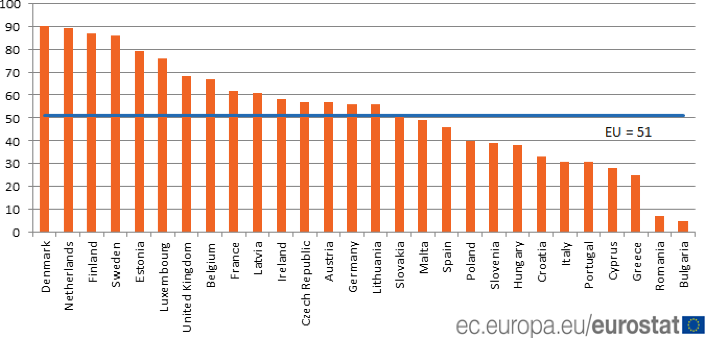

Pic. 1. % of individuals who used internet banking

*Source:* ”Individuals using the internet for internet banking”, Eurostat, 2021.

more comfortable.

People change their behavior and habits in favor of dialog interfaces, as they wait fast and qualified answers. One specialist sometimes may not promptly respond to a client request and needs a pause, in order to either find and answer or transfer request to a more experienced specialist. In this case client has to wait, sometimes for a long time, which can create irritation and, respectively, decrease the level of satisfaction.

One of the leaders of market of professional services in digital technologies, Accenture, in its researches found out that existing online interaction channels are gradually becoming obso- lete. Therefore, banks have to use a brand-new way, by establishing a continuous conversation, in order to eliminate the flaws of models used on a current stage of banking technologies devel- opment. Digital platforms are extremelly important for banks.

By 2017, 51% of bank customers in European Union used internet and mobile banking at least once. And based on the latest trends and situations, the share of internet banking will only grow. Consequently, consumer banks are interested in offering major services via digital channels, and to research and develop modern solutions. However, the main interest is in cre- ating modern, and at the same time, comfortable and usual channel for user interaction, and, especially, for two-way user communication.

Obviously, the closest form of such interaction to live communication would be a form of questions and answers. This form of interaction became widely popular due to search engines and its influence on an internet for the last decade.

People of all generations are used to asking questions on digital platforms. Search engines have been actively developing and implementing technologies related to operating with natural

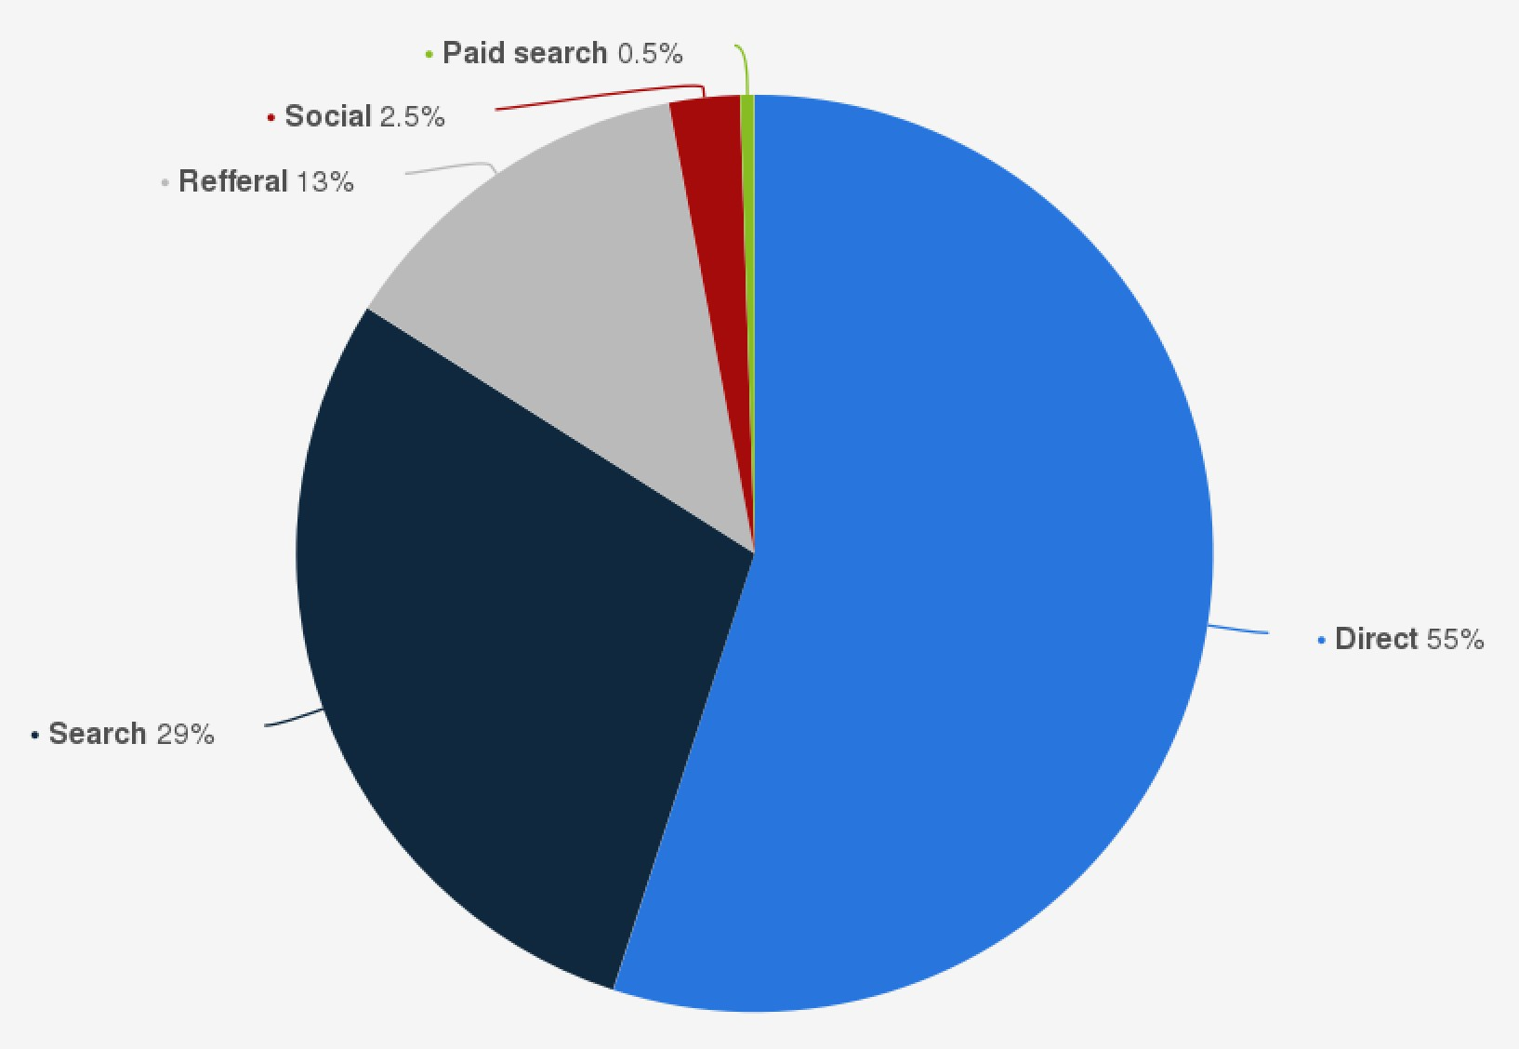

Pic. 2. Distribution of worldwide search traffic

*Source:* Jessica Clement ”Global website traffic distribution”, Statista, 2019.

languages for the last ten years. Same engines have been studying internet users to write proper search queries to obtain expected results for decades.

Nowadays, search engines have nearly 30% of entire internet traffic. Without ten most popular non-search engine websites this share would be around 90%. The influence of search engines on conversation technologies is impossible to overstate. What is even more important, for the last ten years those technologies have been in active development and deployment, re- sulting in existance of a stable branch of technology with a lot of modern solutions.

Natural Language Processing is a cognitive branch of science, that investigates the applica- tion of computational techniques to the analysis and synthesis of natural language and speech. Natural Language Processing, known as NLP, consists of Natural Language Understanding, NLU, which analysis text and finds logical points and meaning, and Natural Language Gener- ation, NLG, which structures, plans and generates human-readable text. Generally, NLP, both Understanding and Generation, including Voice Synthesis, became a pretty common part of technology for a user, especially due to Voice Assistants. What is even more important, for the last ten years the cost of implementation of mentioned technologies significantly decreased. On the contrary, amounts of investements into AI and NLP drastically increase every year. In 2020 global NLP market value was $1.8 billion, and is expected to grow up to $14.4 billion by 2026.

It is important to highlight the exponential grow and compliction of those models. NLP models can have multiple billions of parameters and coefficients, that those use for text analysis

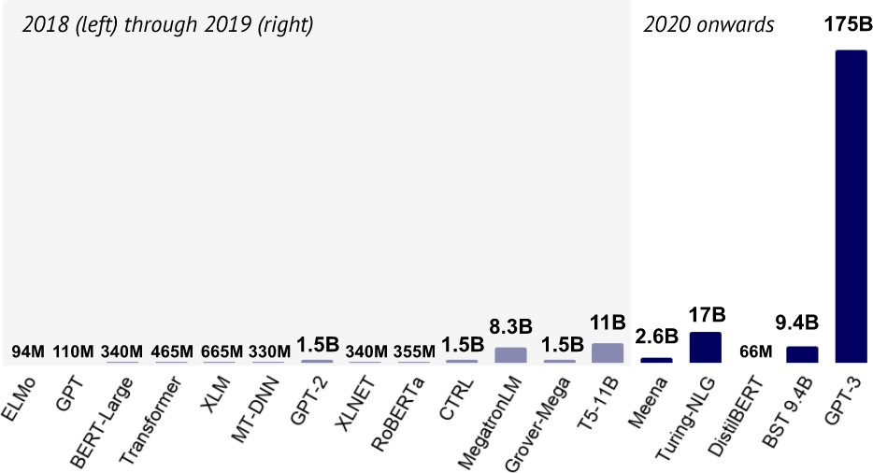

Pic. 3. Number of parameters in NLP AI algorithms

*Source:* Nathan Benaich, Ian Hogarth ”State of AI Report”, stateofai.com, 2020, s. 15.

and generation, with a current record of 175 billion parameters by famous GPT-3.

Main purpose of NLP with AI in this case is to replace usual contact centers and to improve customer experience. The reason of replacement is a comparingly low conversion for existing solutions. Contact centers are infamous for response times and low quality of solutions. This is extremelly important, as consumers have low conversion rates if brands don’t answer phone in under a minute. Based on researches, 78% of responsers may switch brand preferences due to poor response times, while 73% will recommend highly responsive brands. Additionally, 59% of responders have extremelly high conversion rate for highly responsive brands.

At the same time, achieving positive feedback in under a minute is a main target of auto- mated conversational banking. Chat-bots are known for giving high conversion rates and large returns on considerable small inverstments.

In consequence, banks can strive to major influence of dialog interfaces on client, through which clients can transfer funds, send it to other clients, issue card, convert currency, execute payments and various other basic tasks.

It is common to mix up Conversational banking with Mobile and Internet Banking. How- ever, the main difference is in user experience. Mobile and Internet banking are hierarchical trees, both of those have a concrete form. It is always an application, in which user can click buttons, check charts and read text in order to manipulate and make actions. Conversational banking is much more abstract. That is a dialog, client should not in this case know the structure of interaction. In order to achieve something client has to have an intent and, what is even more important, to invoke an action by intention. He doesn’t need to know how to achieve something,

Table 3. Consumer preferences for addressing issues

|  |  |  |  |  |
| --- | --- | --- | --- | --- |
|  | | | | |
|  | | | | 64% |
|  | | | | |
|  | | | 43% | |
|  | | | | |
|  | | 35% | | |
|  | | | | |
|  | | 35% | | |
|  | | | | |
|  | 6% | | | |
|  | | | | |

Calling a service representative Using bank’s live chat or chatbot Going in person to branch Finding an answer on website Reaching out on social media

*Source:* Own study, based on Bill Streeter ”Banking By Bot: Are Chatbots Better Than Real People?”, The Financial Brand, 2018

he can just ask. However, in this case client can rely only on his knowledge, as there would be no buttons or menus to check.

Front-office for Conversational banking may have different forms. This can be a contact center, retail business unit for dialog-based conversation. Couple of years ago, bank client on any problem had to call to a contact center and to talk to customer service line manager. Nowadays, there are other options. Much more interesting option is a messenger, as a front-office for textual interactions. In this case, this can be both a chat-bot in a popular messenger app or a social network, same chat-bot in a mobile or internet banking app, or even a voice assistant.

Currently, it is a popular solution to use chat-bots which can answer to the most simple question, but mostly transfer a conversation to the contact center. Though, this is a not a most effective model, as client firstly has to spend his time to describe his problem to a chat-bot, and then he has to repeat to a human specialist.

However, for customer it is still more comfortable to address problems via common chan- nels of interactions, such as via phone calls or via in-person conversation in a branch.

This is due too negative experience with current automated conversational solutions. It is too early to talk about conversational banking in a poor form, as chat-bots are on such level of development, that those cannot be used purely, as they don’t understand all the requests yet. This results in a negative influence towards client satisfaction.

On the other side, it is important to discuss approaches to build this system. During client conversation it is important to transfer from screen interface of mobile or internet-bank to cre- ation of universal and operational assistant, which would be ready to interact and to help a client at any time. This form of client interaction is based on an understanding of a global trend, as more and more people are used to talk with sellers via messengers. Even though automated solutions are not common, those, nearly 44% of customers would prefer to speak to chatbot, if they are sure, that a chat-bot knows an answer. Therefore, implementing any automatized con- versational interface for a bank is impossible without influencing expectations. This transforms entire service consumption process, as it is more comfortable to contact via suitable and familiar solutions and messengers.

Conversational banking has some significant advantages in comparison to existing sys- tems. Firstly, improvement of client experience. We can make it more comfortable, fast and qualified. Secondly, conversational banking decreases client waiting time. If chat-bot is not sure about the question or the answer, dialog can be transferred to a human operator. In case if system achieves certain level of assurance — it will reply automatically. Researches of client experience had shown that verbal interaction is psychologically more comfortable and brings less cognitive load than visual interface.

From a practical perspective, conversational banking exists in two pure forms. First form is a chat-bot, an automatic solution for textual communication with a client in a form of a dialog window. The input in this case is a text provided by a user, and the output is a text returned by an analytical system, which consumes request and generates response. Second form is a voice assistant. Internal work is analogical to a chat-bot, but it differs in a form of interaction. Voice assistant receives spoken user messages and answers with synthesized voice responses. Both of those forms are well known to users. However, in most cases those are usually used as a support part and do not have sufficient level of autonomy. Application of AI to those well known forms of interaction is the main purpose of Conversational Banking.

Consumers are used to chat and for them, it is easier than to click out their problem in an interface of website or mobile app. The process of automation in banks is gradually growing and this, from the one side, should lead to a reduction of a number of contact center specialists. On the other side, increasing number of customers consequently increases chat loads. Nevertheless, increasing load shows higher client involvement.

Nonetheless, current state of AI application in Front-office has certain problems. As it was mentioned before in 2.1.5., conversational banking is not considered as available by middle- sized and small banks. Mostly it is used either by the largest commercial banks, which have

large amounts of resources available for investments, or by start-ups and new digital financial services, which are targeting market by innovations.

As a result, banks face a choice — use existing solutions or to create their own product, which is not available to small-sized and medium banks. However, it is not entirely correct, as medium-sized and small banks can and have to use third-party solutions for implementation. On the other hand, integration of external technologies uses very large volume of bank resources, as well as cost of product usage. As a result, final cost may be higher than cost of internal development.

Another major problem is obvious and connected to existing employees in customer expe- rience offices. As cost decrease on customer support being a valid reason for banks, this doesn’t mean that banks will decrease amount of support agents. In contrast, those may be moved to other branches or to other banking products. Additionally, support agents may require training for changing their profile. The point of this action is not to decrease a number of employees, but to create a higher percentage of professionals among existing specialists.

## Hybrid approach

Nevertheless, the largest banks already have solutions for dialog interfaces in messengers. In those case, they are developing solutions for artificially augmented intellegence in client sup- port. It is a common misconception, that those chat-bots are for customers only. Indeed, those are much more useful for bank employees as a single source of knowledge and can significantly improve client experience. It is too early to talk about conversational banking in a poor form.

On other side, it is important to discuss approaches to build this system. During client con- versation it is important to transfer from screen interface of mobile or internet-bank to creation of universal and operational assistant, which would be ready to interact and to help a client at any time. This form of client interaction is based on an understanding of a global trend, as more and more people are used to talk with sellers via messengers. This transforms entire service con- sumption process, as it is more comfortable to contact via suitable and familiar solutions and messengers. Conversational banking has some significant advantages in comparison to existing systems.

Firstly, improvement of client experience. We can make it more comfortable, fast and qualified. Secondly, conversational banking decreases client waiting time. If chat-bot is not sure about the question or the answer, dialog can be transferred to a human operator. In case if system achieves certain level of assurance — it will reply automatically. Researches of client

Table 4. Customer Satisfaction Rate by form of Live Chat

Customer satisfaction rate

Conversion with alive agent

60%

Conversion with Artificial Intelligence

88%

68%

*Source:* Own study, based on ”Chatbots are here to stay”, Accenture, 2018

experience had shown that verbal interaction is psychologically more comfortable and brings less cognitive load than visual interface. Even the best market players warn — system should provide connection with a human, as there is no technology, that would allow delegating func- tions to computers entirely.

As well, chat-bot can answer by itself directly. Unfortunately, currently it concerns only the most simple actions — customer welcoming, customer invitation, various forms of apolo- gize, or informing the location of the nearest ATM. If there is a large stream of clients, we can lower the system confidence threshold, in order to transfer clients to chat-bot, which could de- crease waiting time and, as a result, increase client’s service satisfaction. Moreover, it is possible to involve one robot into dialogue with another robot. For example, general support chat-bot can involve investment chat-bot.

Conversational, dialog, bank is a hybrid between classic contact center and automated chat-bot service. However, it is possible to use hybrid approach, in which robot recommends answer to an operator based on existing knowledge base. Of course, the best possible answers are on top of the list, so it would be more comfortable for operator to find. The best possible answer, in this case, would be an answer of the most competent expert, which would allow for an intern to answer on professional level. Every client question and every operator answer are stored in database and is a template for future answers. Operators are teachers and database is a student, and this is the way AI learns. Of course, it requires specialists to develop such a system.

Similar augmentative system can be virtual broker, which give hints based on AI and can pick up an individual way to each client. Nonetheless, there can be a personal-manager service,

Table 5. Fintech AI Use-cases

|  |  |  |  |
| --- | --- | --- | --- |
| **Divisions** | Front office | Middle office | Back office |
| **More mature** | Conversational banking | Anti-fraud, KYC, AML | Credit underwriting |
| **Less mature** | Biometrics | Legal and Compliance | Smart contracts |
| **Savings** | $199 billion | $217 billion | $32 billion |

*Source:* Own study, based on: Lex Sokolin, Matt Low, ”#Machine Intelligence & Augmented Finance”, Autonomous Research, p. 29.

which communicates in chat and can execute large number of operations. This may decrease loads, manual work, to transfer payments form from a manager to an AI. Human-in-the-loop or HITL — a system, in which there should be a person for a proper functioning. Specialist can choose various relevant actions. Manager answers with text messages, as well as with special widgets with portfolio description or with operation confirmation.

Artificial Intelligence has already become a leading driver for technology innovations in banking sector. It has already been developed enough and definitely reliable in everything regarding risks, confidentiality, human factor and marketing strategies.

Nevertheless, AI has already changed financial business and will change it even more in near future. The vast majority of actions, that are being done both in back-office, middle-office and front-office by employees can be automized and algorithmized.

The main interest for banks is in application of AI in front-office and middle-office, as it will lead to significant cost reduction, up to $400 billion in 2025. Banks use AI in front-office for identification and authentication of clients, in order to imitiate alive workers with chat-bots and voice assistants, to deepen relationships with customer, increase engagement, and to offer personalized ideas and recommendations. Additionally, AI is being used in middle-office. It allows detecting and preventing frauds with payments, upgrading processes connected to anti- money laundering processes and detection for know your customer control systems. Those sources of income, which have already been transformed by AI, show the valid way to use this possibility. Nevertheless, those strategies show that banks have to create holistic strategy, which would connect and cover multiple scopes of banking, sources of useful data, third-parties and employees.

However, with all the advantages of modern software, forecasts of full robotization prob- ably won’t be realized, as in near future it is unlikely for a program to replace a person.

In order to integrate the foregoing into existing banking service it is necessary for banking platform to support it. Obviously, those platforms, which current banking stands on were devel- oped around 15-30 years ago, or even more, and this makes integration of modern algorithms almost impossible. This is why modern banks are now puzzled if it is possible to reengineer their

software in order to have an effective possibility to embed Artificial Intelligence and Machine Learning in its banking platform.

Nevertheless, it is extremely important to remember, that automating workplaces doesn’t always lead to dismissal of workers. It is important to create retraining programs, that would allow existing employees to obtain new skills in fields, that are out of risk of automation, in order to decrease automation’s influence on labour market.

Increasing number of internet users, availability of smartphones and other handheld de- vices, and rapid development of mobile internet forms new users’ habits and behaviors. Social network users and mobile app users are more and more focused on getting instant results and target specific actions with the lowest amount of clicks possible.

However, the need of receiving high-quality financial services and personal consultations hasn’t disappeared: people are still calling to call-centers. Even though remote banking service systems are rapidly developing, number of phone calls recently significantly increased.

Nevertheless, there are good news for banks that have yet to embark on their AI journey. Making progress in AI does not require an unbearable effort. It typically begins with identifying your organizational goals, readying your data and finding the right partners. Nonetheless, even medium-sized and small banks have to investigate this topic by now, as in future, gap between AI users and nonuser will only widen.

# CHAPTER III

## Research survey: Chat-bots as a new approach

## Chat-bots. Overview and theoretical aspect

Chatbot — is a complex multivariate algorithm, which is able to perceive information in the simplest and most understandable for the people form — dialogue. In the process of communication with a person, chatbot analyzes lexical data and forms logically correct answers. As a most common example, with the help of chatbot, now it is possible to order pizza, find suitable flight and hotel, set necessary system parameters, set an alarm clock or find up-to-date weather or sport information.

Chatbots from a highly specialized, most often non-profit, entertainment turn into a tool. Previously, chatbots were considered as a highly specialized solution, as an entertainment and as a proof-of-concept. Nowadays, it is being understanded as a necessary tool for all kinds of messengers, social networks and applications.

Chatbots are recreating whole IT ecosystem landscape. Even though for the user it is just a companion program that is designed to help, on the other side there is always a complex system, based on a couple of AI technologies. Obviously, it is entirely new industry of service and assisting.

Generally, chatbots perform three main groups of tasks:

* + 1. Executing routine common operations, that could be translated to a specific algorithm
    2. Search and data aggregation — chatbots are able to collect material on a given topic and form it in a certain way
    3. First line of customer service — in addition to providing advices on goods and services, chatbots can focus user attention or entertain him, although most of the chatbots can only answer to basic questions.

Rule-based chat-bots with pregenerated and specified workflow exist from the very be- ginning of IT. However, AI-powered solutions are comparingly new. The biggest impact in the last decade was done by Apple and its voice assistant Siri in 2010. It would be impossible to create such solution without Natural Language Processing and Machine Learning technologies. However, the main reason was due to full control of operational system they were able to build a market.

The second wave of AI popularity was due in 2016, when Facebook made a bot platform, which allowed to create AI-powered bots inside social network. This showed practical impor- tance of such technologies and was a main driving force of further practical applicaton on AI in front-offices in various industries. As a result, apart from being the biggest social network, with 3 billion monthly active users , and an important channel of customer communication, Facebook obtained a massive influence on chatbot market and is one of the main catalyst of growth of this market. Moreover, Facebook invested significant funds into development of speech technolo- gies, creating both toolkits for developers and developing and new sells channels, which made AI chatbots with NLP even more accessible.

Starting from 2017 banks, various financial and insurance companies started showing in- terest toward chatbots with AI. Moreover, same year some of them developed and integrated automatic communication technologies in client communications. The first global banking chat- bot hit was Bank of America’s Erica in 2016, an AI-powered financial assistant embedded in its mobile banking app, recently passed 20 million users with more than 105 million interactions. As another proper example is a Citi Bot by Citibank, which was developed in 2018, received a hude success among Facebook users.

In 2018 volume of the global chatbot market reached $1.27 billion. Moreover, experts expect that starting in 2024 global spending on dialog services with Artificial Intelligence will be increasing by 34.75% and will achieve $7.59 billion until the end of 2024.

Even though by the end of 2021 the quality of chatbot implementations was on a pretty low level, its popularity is growing rapidly. On the other hand, the positive effect will be brought by massive consumption of services of devices with NLU support, for example, smart speakers, or voice interfaces for mobile applications. This leads to popularization of voice control, due to its expluatation convenience and possible automation of routine processes, as those speakers usually can work as a voice controlled assistant. Henceforth, by 2025 existence of talking chat- bots, de-facto, will become the norm for most of the internet services.

Chatbot technology is quite in demand by marketing departments of various companies for quick contact with potential customers, as well as online customer support organizations. Chatbots act as a customer manager services or as a support specialist. Company, which uses this technology, can obtain both an advantage, for example, reduced staff costs, and a disadvantage

— outflow of clients who do not want to conduct a dialogue with the ”computer”. Consequently, chat-bot technology allows optimizing business-processes and find out reasonable compromise in simplifying client interaction with bankers with simultaneous increase of level of service and cost reducement on call-centers and SMS notification services. Dialog imitation should occur

in a familiar and comfortable for client environment, and at the same time client should receive choice of services which previously wasn’t available via website or remote business service systems, so it could store and raise client loyalty.

Unfortunately, text recognition and natural language processing are an avant-garde frontier of Artificial Intelligence, and it still has to be brought up to an acceptable level. Popularity of promising, according to multiple companies, of so-called interface bots, that are based on Social Network platforms, for example, Facebook, do not provide high-quality imitation of live conversation and do not maintain customer loyalty. Those conversational bots are usually being criticized, especially its more primitive analogues, as they still have limitations to have a mindful dialog. Discussing issues clients are still in need of sense of live content and due to this the most promising direction is the development of conversational chat-bots, but only given that there are wide possibilities of language processing and analysis. It would be extremely hard, but still possible to create a true chat-bot, that would be able to imitate human speech with high quality.

This solution will significantly decrease load on a call-center and keep the possibility of live dialogue in specific corner cases. Additionally, this technology allows to create a specific subtype of chatbots, although it is more common, as it is being developed and supported by major companies of IT market — personal assistants. Hundreds millions of people are interacting with personal digital assistants on such platforms as Google, Apple, Amazon, Facebook and others. Digital Assistants are a specific subtype of chatbots, although it is more common, as it is being developed and supported by major companies of IT market. Hundreds millions of people are interacting with personal digital assistants on such platforms as Google, Apple, Amazon, Facebook and others. Textual and voice communication with user makes the transition from Graphical User Interface towards Conversational User Interface, which can be the key trend for the coming years.

Textual and voice communication with user makes the transition from Graphical User In- terface towards Conversational User Interface, which can be the key trend for the coming years. Many messenger apps, for example, Facebook Messenger, have public APIs — programming interface, which allows creating chatbots. Companies can use those apps as intermediaries in order to increase performance of its employees.

Additionally, those can be a new channel for client service, either via corporate website, or by some new service channel. Uber allows to order a car via Facebook Messenger. But extremelly important is the launch of Amazon Alexa, that can be used by third-party companies for customer communication, as well as integrated into different user devices, like smartphones, smart speakers and any other devices with sound input, sound output and internet connection.

Nevertheless, chatbots are not just a simple frontend. Firstly, banks can use same chatbot communication channel for notifications to increase level of client engagement. In general, live chat can be used as a direct client communication channel with clients. Information on product specs and services, contact info, payments proceeding, financial recommendations. Secondly, large amount of client data allows making targetized, individual decisions and solutions. This is a strong strategical advantage, as correct account information would allow more precisely offer personal recommendations. Moreover, large amount of client data allows making more targeted decisions without using exclusively strategic approach. Account information and its nature allows more correctly approach personal offers.

Chat-bot is not an end in itself, but an instrument for checking and testing. The only practical sense in chatbots are in costs reduction, not in profit generation. On the other hand, high growth rates of chatbot market with NLP technologies is due to early stage of its formation.

Among the main problems, hindering the use of this technology, the main problem is poor user awareness of functionality, quality and convenience of services. However, developers are trying to eliminate those disadvantages by launching various interactive features. Despite having the greatest prospects in reducing costs for call centers and other support services, this technol- ogy has a great advantage in direct customer services. Digital assistants would be able to make catalog navigation easier catalogs and offer users desired products. Since local business is ag- gressively integrating Artificial Intelligence, future increasing costs of development of chatbots is just a matter of time, as it would significantly decrease costs on customer service services.

Significant change is expected in Asia-Pacific region due to large amount of people and historically smartphone-oriented digital market. Scientists of Temple University and Fudan Uni- versity conducted a study among 6000 clients of financial service company. All clients were talking either to chatbots or real people without expirience in sales. Disclosure of the “identity” of the interlocutor was carried out at the beginning of the conversation or at the end, after the purchase. Moreover, in several groups the “identity” was not disclosed. AI turned out to be 4 times more effective than an ordinary unexperienced employee. However, if client founds out the company uses a chatbot before buying, the sale chance drop by more than 79.7%. According to researchers, these results shouldn’t restrain usage of chatbots. AI has undeniable technologi- cal advantages, which allow reducing prices by reducing the cost of manual labor. In addition, marketers would have to take this research into account and increase customer confidence in chat robots.

The main feature is that chat-bots require same decision-making system as any other fron- tend, and is dependent of every single client. This, in its turn, receives the biggest profit from

Table 6. Chat-bot solutions with NLP AI

|  |  |
| --- | --- |
| **Open-source** | Rasa, DeepPavlov.ai |
| **ML&AI solutions** | LiveChat, Kore.ai with BankAssist, Kasisto,  Morph.ai, Imperson.ai, Streebo, Creative Virtual, Artificial Solutions |
| **IT Corporations** | IBM Watson, Google Dialogflow, Amazon Lex,  SAP Recast.ai, Baidu KITT.ai, Facebook Messenger Platform, Microsoft LUIS, Microsoft Azure Bot |

*Source:* Own study

PSD2 and Open Banking Initiative.

In order to implement such an automated conversational solution banks can either de- velop their own solutions from the very roots, use existing available instruments for individual custom solutions, or to apply available third-party options offered by specialized companies. Current stage of ML technologies allows for companies to access NLP with considerably low costs for own implementation. Modern programming technologies have various technologies and programming libraries for creation of NLP systems and many companies for advanced sup- port. Among most promising open-source solutions are DeepPavlov.ai and Rasa. Those allow creation of own Natural Language Processing systems based on community support.

On the other hand, there are a lot of NLP start-ups, that focus on AI chatbots of various complexity. Among those are LiveChat, Kore.ai with BankAssist, Kasisto, Morph.ai, Imper- son.ai, Streebo, Creative Virtual and Artificial Solutions.

What is even more important, large IT corporations have their own solutions, resulting in easier form of integration with existing infrastructure. Among those are IBM Watson, Google Dialogflow, Amazon Lex, SAP Recast.ai, Baidu KITT.ai, Facebook Messenger Platform. The leader of those is currently Microsoft, which has Azure Bot Service, Semantic Machines and LUIS, Microsoft Language Understanding Intelligent Service. Proper analyzes of possibilities require proper classification of chatbots by features.

Firstly, by types of interaction. User can interact with chatbot either by voice, or by text.

The same is true for chatbot, as it can answer either by generated speech or generated text.

* Text
* Voice

Secondly, by front platform, by form of user interaction:

* Application
* Third-party messenger
* Operating system

The reasoning behind this is in a possible platform of interaction with user. Chatbot can be in a form of either part of mobile or desktop application, or as a part of web application. Obviously, in this case user has to know and have access to website or mobile application for proper interaction. Secondly, chatbot can be based on a third-party messenger, such as Facebook Messenger. Thirdly, chatbot can be integrated with an operating system assistant. For example, with Apple Siri on iOS and macOS devices, Cortana on Windows devices or Google Assistant on Android devices.

Additionally, we cannot ignore different forms of ownership.

* Software-as-a-Service
* Internal development

Banks can use chatbots both using third-party tools, where chatbot ownership is on a side of third-party service, or as an internal tool with internal development.

It should not be ignored, that chatbots can be used and developed differently for different end users. By end user those can be divided to:

* Customer-oriented
* Employee-oriented

The last and, probably, the most important internal classification is by decision-making process:

* Rule-Based
* Machine learning

Rule-based chatbots are comparingly simple, as those are being built by a set of branch algorithms with limited number of options. Machine Learning based chatbots, in its turn, can adapt to everchanging environment and create new answers, notifications and other forms of interaction based on a single client or a group of clients.

Table 7. Forms of user interaction by type

|  |  |  |
| --- | --- | --- |
|  | **Input** | **Output** |
| **Voice** | Microphone | Speaker |
| **Text** | Input field | Display |

*Source:* Own study

## Structure

Structurully, chatbot can be divided into 3 parts — frontend, middleware and backend. Frontend defines user interface, a form of a user interaction both textual and by voice. Middle- ware is a rule-based or Machine Learning based decoder and parser, which receives an input from frontend, produces commands with input arguments, passes to backend, and generates text or voice message based on backend response. Backend, accordingly, executes commands with input arguments and produces output, based on an internal banking logic. As it is possible to observe, from functional aspect it is not import either this is a textual chat-bot or is invoked by voice. Those differ only by the frontend for the user. In both solutions we have to use Natural Language Programming technologies to either transform text or speech into commands valid for backend API. Such an architecture allows building conversational solutions in a form of simple, on interface level, blocks.

## Frontend

Frontend is an interface for a user of a conversational bot. Interaction can be done by voice or text both for input and output.

In case of voice interaction input is being received by a microphone, via which user speaks, and output is done via speaker of a mobile phone or a computer with generated speech. For textual interaction input is done by a text field, usually done with a keyboard, while output is shown on screen, usually as a text message.

Overwhelmingly, as a frontend, chatbots use textual dialog messenger and usually are associated with this form. In this use-case customer write via suitable messenger, social network or application in an extremelly familiar environment. Obviously, familiarity is also connected to prior existance of customer support dialogs in any form. Nonetheless, as it was mentioned before, this is only a form of interaction, not a logic by itself and not the most labor-intensive part of the chatbot.

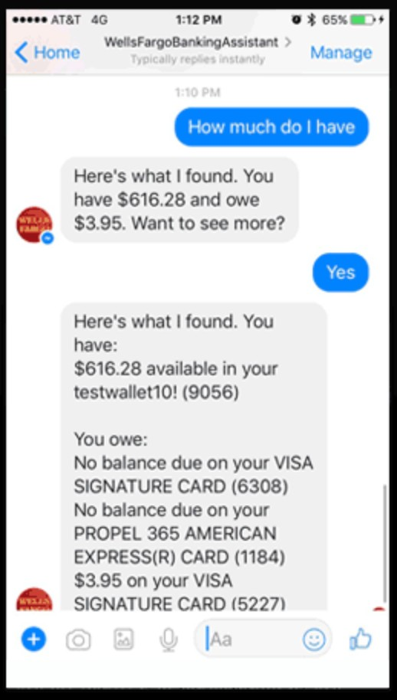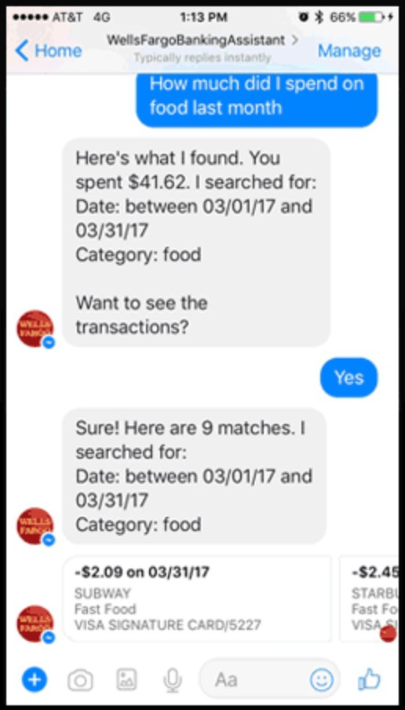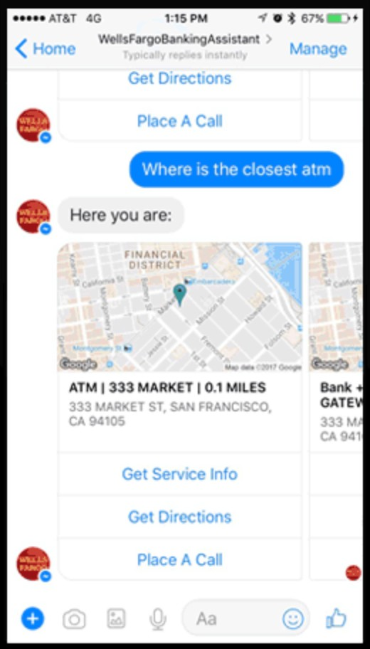

Pic. 4. Frontend of a Bank Assistant chat-bot by Wells Fargo on a Facebook

*Source:* Own study

## Middleware

Input received from frontend is passed to middleware. Middleware can be either on a bank side, or on some third-party service. Middleware is required for preprocesing of an input for processing on a bank side, or for postprocessing of an output received from a bank side for proper customer understanding. In other words, this is a part of logic not connected to banking operations, but is required for proper understanding on both sides of interaction.

The most simple case is for Rule-based decision-making. For this option there is no need to use complicated Statistics and Machine Learning knowledge, but input is represented by limited set of options and output is presented as a filled template answer. This case is preferred for faster chat-bot development, or for a chat-bot on an employee side, which is hidden from a client.

Nevertheless, middleware can have a much more complicated form. Ideally, this is the first frontier of Artificial Intelligence and Machine Learning technics in chatbots However, it is not used for analytics, but mainly for Natural Language Processing.

Natural Language Processing, NLP, divides in two parts — Natural Language Understand- ing and Natural Language Generation. Natural Language Understanding is a branch of NLP which uses Artificial Intelligence, mostly Machine Learning technics, for building software to understand input in the form of sentences using text or speech. Natural Language Generation is a branch of NLP which uses Artificial Intelligence, mostly Machine Learning technics, for

building software to generate text and synthesize tet.

Accordingly, Conversational Banking has to be created with two instruments, Natural Language Understanding for input and Natural Language Generation for output. Moreover, same middleware can be used for various forms, as a text or speech understanding framework for call-center bots, website chatbots or roboadvisers and for text or speech generation for SMS, text answers or cold calling.

## Backend

Backend part of any conversational interaction is the most important from a banking side, as it is directly connected to banking processes. This part is actual part of execution of trans- actions, request or for other orders of operations, including current balance check. Moreover, it is inextricably linked with actual bank as a platform for financial services. In comparison to frontend, interface for bank interaction has to be strictly formulated and defined, as, basically, this represents API, application programming interface, of a bank.

The most intense usage of AI is possible here and can be shared with all levels of banking. The root source of data for decision-making based on AI is a metadata collected from requests. As those request interface is strictly formulated, it is possible to define which type of data to col- lect, obviously, confirmed to GDPR regulations and requirements, and after proper anonymizing of corresponding data. Backend of a chatbot should be connected to general recommendation system of a bank, as conversational banking, from a bank perspective, is yet another channel for client interaction. Obviously, mentioned recommendation system is a main source of Machine Learning based decision-making, as it can build unpredictable models of client behaviour, both individual and as a group, and based on those models observe future client trends, give recom- mendations and what is even more important, contact with a client based on a made decision.

Secondly, this is a place for AI to learn customer related questions not connected to bank services, but to regulations. For example, using supervised learning AI can learn, based on previous answers by a contact center, what documents client need to open current account or be informed about entire process of opening brokerage account.

## Conclusion

Chatbots are an extremelly form of client interaction. Even though latest achievements of Artificial Intelligence can and has to be applied to banking, those can be comparingly in- dependent and developed separately and parallelly by different parties. Moreover, those parts can be connected to existing banking services and interfaces and don’t require changes other, than those required by modern banking regulations or Open Banking philosophy. Banks can use same chatbot communication channel for notifications to increase level of client engage- ment. In general, live chat can be used as a direct client communication channel with clients, provide information on product specs and services, contact info, payments proceeding, financial recommendations and many other goods and services.

It is possible to highlight several trends, which may have the most significant impact on the development of the chatbot industry in the near future. Firstly, growth of share of combined solutions, in which robots are not able to replace human completely, but complement for repeat- ing routine activities. The most promising among of them are assistants for human operators, that are integrated with Robotic Process Automation. The second trend is the development of tools for business intelligence data mining and building ontologies for unstructured data. In other words, those are the systems into which it is possible to upload a variety of texts, and it will automatically extract semantic connections and build language models, specific for that certain domain. Lastly, shareable knowledge between different chatbots and chatbot platforms. That would allow creating personified virtual assistants, with the special “personality” for each client. As a result, we can say that Artificial Intelligence and Machine Learning mostly are being used by Front Office in a hidden for an ordinary man.

## Strategy of a chat-bot solution

Developing a chat-bot for a financial institution is expected to bring high costs and con- sume lots of time. However, consequent approach to chat-bot development will lead to iterative process and precise control over development of new form of client interaction. Existing market situation already requires certain mechanism, that are required for Conversational Banking. In Europe PSD2 made a major influence by forcing banks to make public APIs for payments and accounts. Even though it required a lot of work, things done may become a foundation for a global Bank-as-a-Service wave of popularity. Besides, iterative approach with proper strategy would lead to adaptation to current trends and forecast future trends.

Table 8. Current route of a user request to a bank

Internal API of a Bank

Internet or mobile banking

User of services

Third-party service providers

*Source:* Own study

Public API of a Bank

Nowadays, Open Banking is one of the most important innovations in banking. Moreover, the latest requirements of Bank Regulators all over the world demand this innovation. Thus, granting access to more banking activities and services is an obvious trend.

Currently, PSD2 demand only a small subset of operation, initiation of payments and ac- count check. However, this had already forced banks to know how to make secured public APIs according to regulations. As a set of possible operation using third-party providers is limited, we can assure that there are two APIs, for internal usage and for public usage.

Accordingly, internal bank API is used for official bank’s internet banking web application or mobile banking application. Obviously, same internal API can be used for internal usage among internal bank services. More or less, mentioned graph represents current state of banking interaction with third-party services from a client side.

## Open Banking API development and extension

In ideal world it would be easy and comfortable for banks to make entire API public and supportable. This would allow banks to focus on financial operations and stability, instead of front-offices. Unfortunately, this is not possible due to tactical reasons and obvious risks for such major changes. Nevertheless, we can assume that certain forms of financial services can be used via public API.

API is a programming interface from a set of ready-made functions or structures that are provided by an application or service. This API has to support as many banking services, as pos- sible, both for registered, bank, users and newcomers. Among those services could be, among PSD2-based balance check and setting payments, as listing public or individual offers, loan

Table 9. Open Banking User Request Route

User of services

Internet or mobile banking

Public API of a Bank

Third-party service providers

*Source:* Own study

requirements check, deposit terms, additional services and legal information.

As a second step, banks have to make mentioned API public or licensible. Basically, this would allow for bank to work in a Bank-as-a-Service business model in a more abstract way. The reasoning behind this is in high costs of internal solutions. Additionally, bank may not be interested or cannot allow for itself to invest into risky forms of client interaction. Bank-as-a- Service model for third-party FinTechs is an applyable option in this case, as it would allow transfering customer interaction risks to FinTechs. This is the very first step where AI is useble in any form. Basically, this step represents risk deduction by allowing FinTech using Bank-as-a- Service. How to create client interaction, how to analyze client interaction and how to interpret results becomes a problem for third-parties.

In this case, bank can check and validate strategies done by third-parties for client interac- tion, and in case of positive impact bank can decide what is more applyable — either to continue serving as a service bank, or to create new ways of client interaction by itself.

This development would lead to a major move towards Bank-as-a-Service. Allowing third-party providers to use bank’s own services via API on defined and specified requirements would lead to partly delegation of front-office functions to those third-parties, as those can fo- cus on B2C cooperation and find clients more precisely and in more effective way, especially by uniting services of multiple Banks-as-a-Services. Mentioned operations would inevitably result in risky, state-of-art FinTech start-ups. As a result, Conversational Banking solution can be created by a FinTech start-up, resulting in a next operational scheme.

Even though it looks like innovation, actually this is an evolution. If bank decide to turn to Conversational Banking in all cases it has to create secure API for multiple operations not covered by, for example, PSD2 yet. It is a wise option to share API for third-party service providers, as it would allow testing innovations by costs of third-party providers.

Table 10. Open Banking User Request Route with Conversational Banking

Third-party conversational banking

User of services

Internet or mobile banking

Public API of a Bank

Third-party service providers

*Source:* Own study

Table 11. User Request Route with Rule-based middleware

User of services

Public API of a Bank





Front-office employee

Knowledge database

*Source:* Own study

Conversational API of a Bank

Rule-based middleware

## Rule-based middleware

Undoubtedly, bank should not rely only on third-parties, but has to create own solutions. Firstly, bank has to create comparingly simple and low-cost middleware for a chat-bot. Of course, this is not an Artificial Intelligence, as it may require big investments, but a more simple, rule-based algorithmical solution. Unfortunately, in both cases additional costs are required on a front-end level, either some user interface changes in mobile and internet banking application, as a chat window for bot is required. On the other hand, an additional application for front-office employees is required, if banks decide to make a hybrid chat-bot approach.

Additional costs are required on a backend side for a Conversational API, which should handle requests from middleware and return formed responses. As well, Conversational API has to use knowledge database, which has predefined answers for most popular questions or some templates.

Table 12. Open Banking User Request Route with ML&AI Conversational Banking

Conversational API of a Bank

Public API of a Bank

|  |  |  |
| --- | --- | --- |
| Front-office employee |  | Bank’s middleware with ML&AI |
|  |

|  |  |  |
| --- | --- | --- |
| User of services |  | Third-party middleware with ML&AI |
|  |

*Source:* Own study

Knowledge database

Table 13. Structure of an integrated chat-bot solution

CRM

Chat-bot

User

Database

*Source:* Own study

## Middleware with Machine Learning

The most ambitious, innovative and risky form of a chat-bot would be a chat-bot which uses Artificial Intelligence, Machine Learning and Natural Language Processing technics for client communication. Entire processing would be done on a middleware between a user inter- face, which is used either by a client or an employee, and a bank’s backend API.

Machine Learning based middleware, either third-party or owned and developed by bank, processes human-writeable text to a form of a backend request and generates human-readable answer based on a response received from a bank backend.

Basically, an ideal system should be just an intermediate block of logic, that receives message from a client, determines business related data and transfers it to customer relationship management system. Accordingly, CRM system returns data, which is used by a mentioned block of logic, which returns human-readable format. Of course, it has to use various databases of known question-answer pairs and lists of promoted products.

Unfortunately, this type of system would be significantly complicated and requires more precise analysis and planning. Firstly, a user-input message has to pass data cleansing and go to

NLU engine, which transforms a message into contextual keywords, which would allow dialog manager to handle. More simple forms, which can be templated or is a common knowledge, for example, currency rates, can be received via database of questions and answers. More com- plicated logic has to be handled in Dialog Manager. As a result, formed response passes to NLG engine, which generates text or synthesizes speech, which is passed as an output to user. Obviously, for development reasons dialog has to be collected and analyzed with metadata. Ac- cordingly, Artificial Intelligence is a main logical solution for Natural Language Understanding, Natural Language Generation, Dialog Manager and Analytics.

## Recommendations and notifications

However, AI in a chat-bot is not limited to practical use in terms of Natural Language Processing. AI can be used to create powerful recommendation and notification system, based on existing categories of users and their preferences.

Every request received may have metainformation, as popular keywords, popular requests, which in pair with known customer information, as age, location, gender, et cetera, allows bank to build recommendation system based on a Machine Learning solutions. Nonetheless, this can be done both on a bank side, as on third-party solution, resulting in a Bank-as-a-Platform form of development in this case.

Obviously, generated recommendations should be somehow delivered to a user. This can be done not only by a common form of web, mobile or SMS notifications, but also in a form of a message via same chat-bot, which is an important form of communication initiation from a bank’s side in case of chat-bots in social networks and third-party messengers.

## Summary of approaches

Every stage can be done in 3 possible ways:

* + - 1. Software-as-a-Service
      2. Solution on premise
      3. In-house development

The cheapest and fastest way would be to use Software-as-a-Service solution, which has minimal technical requirements, requires minimal maintenance and just has to be integrated into bank’s infrastructure. On the other hand, usually there is no possibility to customize men-

Table 14. Structure of a ML&AI Chat-bot solution with Natural Language Processing

Dialog Manager (DM)

Nature Language Understanding (NLU)

Dialog log

Analytics

*Input*

Data cleansing

Messenger

*Keywords*

*Output*

*Next question*

Nature Language Generator (NLG)

58

Database of questions and answers

*Source:* Own study

Table 15. Plan of integration of a ML&AI Recommendation and Notification systems

ML&AI Recommendations

Analytics engine

Conversational API of a Bank

Public API of a Bank

Knowledge database

*Source:* Own study

Notifications

Table 16. Average costs of PSD2 implementation

|  |  |  |  |
| --- | --- | --- | --- |
|  | **Development costs, $** | **Annual fees, $** | **Time, months** |
| **Software-as-a-Service** | 15’000-30’000 | 30’000-300’000 | 1-3 |
| **Solution on premise** | 500’000 | 100’000 | 6-18 |
| **In-house development** | 200’000-1’000’000 | 50’000-200’000 | 12-24 |

*Source:* Own study, based on ”European PSD2 Survey Results highlights”, Deloitte, 2017, p.5.

tioned solution and requires additional vendor support. Moreover, finding a proper vendor is a complicated task, as a vendor has to have banking experience and proof-of-work.

As an option, bank can interact with a vendor to create solution on premise. In this case it would be entirely controllable and suited to bank’s needs. Contrarily, it would require much more resources for both integration process and support.

The most precise and leading option for every bank would be to create own in-house solu- tion, which would, obviously, give bank entire control over both support, costs, efficiency and services supported. Nevertheless, this is the most expensive solution both in costs and time con- sumption, as it would not only require to build additional divisions both for development and maintenance, but also requires in-depth understanding of various technical and security stan- dards. According to studies, implementation costs time consumption of PSD2 varied drastically based on a chosen way of development and size of a bank.

As it was mentioned before, public API is a wider approach, which is based on infras- tructure and system provided during implementation of PSD2. As a result, in my opinion it is possible to apply same expectations to development of public API.

The next step is to build a cheaper version of middleware, rule-based. What is even more

Table 17. Expected costs of an Open Banking API implementation

|  |  |  |  |
| --- | --- | --- | --- |
|  | **Development costs, $** | **Annual fees, $** | **Time, months** |
| **Software-as-a-Service** | 15’000-30’000 | 30’000-300’000 | 1-3 |
| **Solution on premise** | 500’000+ | 100’000+ | 6-18 |
| **In-house development** | 200’000-1’000’000 | 50’000-200’000 | 12-24 |

*Source:* Own study

Table 18. Expected costs of a Rule-based middleware solution

|  |  |  |  |
| --- | --- | --- | --- |
|  | **Development costs, $** | **Annual fees, $** | **Time, months** |
| **Software-as-a-Service** | 10’000-25’000 | 25’000-60’000 | 1-3 |
| **Solution on premise** | 50’000+ | 50’000+ | 4-6 |
| **In-house development** | 100’000+ | 50’000+ | 4-6 |

*Source:* Own study

important, in case of having sufficient budget, this solution can be done in parallel with API extension and UI of front-office development. Therefore, time to market for middleware highly depends on chosen strategy and available budget.

Next logical step would be creation of Machine Learning based middleware. This step is the most intense and the most expensive stage. Additionally, this stage cannot be done paral- lely with other stages, as it requires enormous investments and development involvement, which adversely affect time consumption. However, it is not the only negative affect, as this stage addi- tionally requires using supervised Machine Learning, which requires sequential time-consuming stages, as data collection, teaching process and model testing. Nevertheless, time to market is even longer if this middleware has to be used for customer related chat-bot, as, firstly, it has to be used by employees. The best use-case would be to use hybrid chat-bot approach, which allows unsupervised learning by observing dialog between employee and a client at first. Secondly, employee would just be an additional layer between middleware and chat-bot, which results in a supervised learning, where employee is the teacher. Mentioned strategy allows developing highly efficient chat-bot without need to test in production on existing users.

Machine Learning based chat-bot with Natural Language Processing is an extremelly ef- ficient banking solution. It allows supplying content and information based on a habits and

Table 19. Expected costs of a ML&AI middleware solution

|  |  |  |  |
| --- | --- | --- | --- |
|  | **Development costs, $** | **Annual fees, $** | **Time, months** |
| **Software-as-a-Service** | 25’000-50’000 | 25’000-50’000 | 4-6 |
| **Solution on premise** | 150’000-500’000 | 50’000 | 6-9 |
| **In-house development** | 300’000-1’000’000 | 50’000-200’000 | 9-15 |

*Source:* Own study

Table 20. Expected costs of ML&AI-based Recommendation and Notification solution

|  |  |  |  |
| --- | --- | --- | --- |
|  | **Development costs, $** | **Annual fees, $** | **Time, months** |
| **Software-as-a-Service** | 15’000-30’000 | 6’000-15’000 | 1-3 |
| **Solution on premise** | 25’000-50’000 | 10’000-25’000 | 1-3 |
| **In-house development** | 100’000-300’000 | 50’000-100’000 | 4-6 |

*Source:* Own study

Table 21. Expected costs of an AI NLP Chat-bot solution with Recommendations

|  |  |  |  |
| --- | --- | --- | --- |
|  | **Development costs, $** | **Annual fees, $** | **Time, months** |
| **Software-as-a-Service** | 65’000-135’000 | 86’000-425’000 | 6-12 |
| **Solution on premise** | 725’000-1’100’00 | 210’000-300’000 | 9-18 |
| **In-house development** | 700’000-2’500’000 | 200’000-550’000 | 12-24 |

*Source:* Own study

requirements of a user. Especially, it increases user engagement due to fast replies and un- derstandable form of help. However, chat-bot by form of user interaction does not answer the questions, which user does not ask. As a result, user cannot ask about the services he does not know about. Moreover, this solution does not cover purposes of bank growth and development. In order to fulfil those banking needs, additional system of recommendations and noti- fications is required. This system should allow based on existing, known customer data give personalized recommendations either by form of additional answers in a chat-bot, dialog initia-

tion message or notifications.

As a result, bank would be able to create new system, a chat-bot with high levels of user engagement and a farseeing growth basis. Existing forms of development are extremelly flexible and can suit any forms of budget and time available. Banks can choose a level of influence and control over product based on their needs. Nonetheless, entire system and approach is a very risky form of investment and should be extremelly precisely analyzed by management.

## Research design

As it was previously analyzed, chat-bot solution may require both a lot of time and a lot of resources to develop. Intuitively, we may expect mentioned ML&AI-based chat-bots to be an ideal, automated solution for cost decrease and effective customer support. Unfortunately, banking clients may have subjectively negative opinion on existing rule-based chat-bots, which are usually considered as an avant-garde of customer support, but may not help properly client needs.

Figure. 5. Ages of respondents

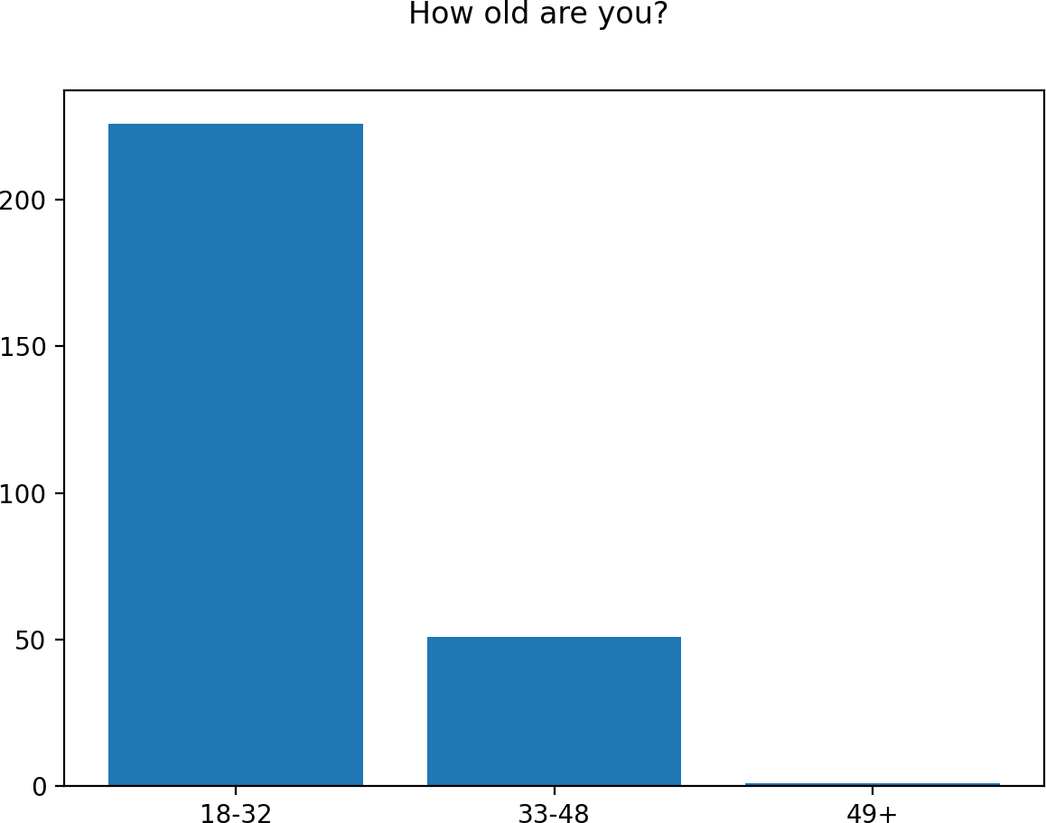

*Source:* Own study.

Therefore, survey was conducted in order to determine current level of satisfaction with front-office. In entire survey 278 respondents were involved.

First question was to build an age portrait. Age answers were divided in three categories based on generation experience with dialog interfaces. First group lower limit of 18 years was chosen due to socially acceptable age of responsibility. First group upper limit of 32 years was chosen as dialog interfaces became most viable nearly 15 years ago, resulting in experienced users of dialog interfaces. Second group upper limit was chosen based on a socially acceptable middle-age medium. It is possible to observe dominance of young generation among respon- dents.

On the other hand, second question had shown high levels experience of banking interac- tions among respondents, as more than a half of respondents used services of 2 or more banks for the last year.

However, next two questions, question about satisfaction with banking interactions and question about satisfaction with problem-solving, had shown slightly negative feeling towards existing customer support systems.

At the same time, even though most of the researches had shown general dissatisfaction with response times, respondents of this survey were more loyal and showed neutrality.

Next question confirmed hypothesis about survey population and showed that respondents mostly prefer dialog interactions over phone calls.

……………………..

**3.3.1 Research Population and Data Collection**

One of the most interesting results is high assurance of respondents that they know when they walk with a chat-bot, and not a human employee.

However, I suspect this is connected to significant dissatisfaction with chat-bots, as there

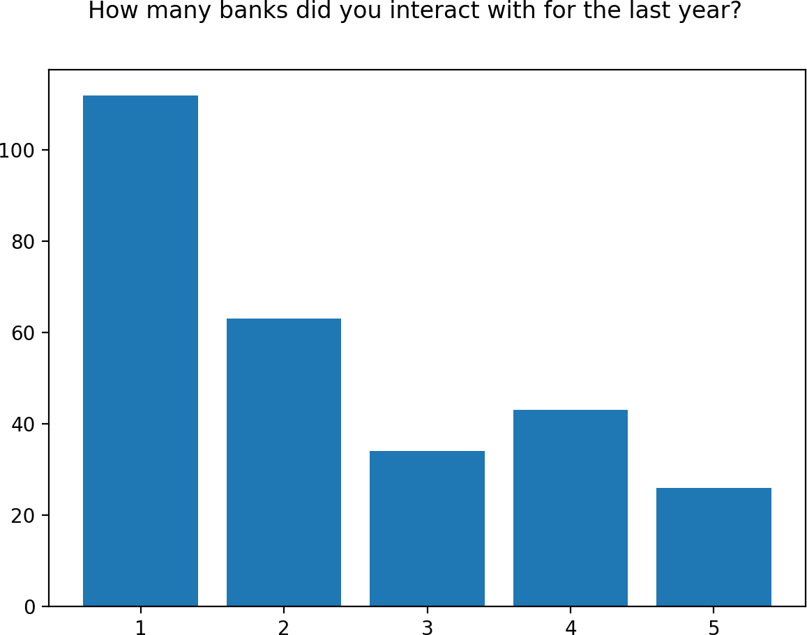

Pic. 6. Number of banks per respondent

*Source:* Own study.

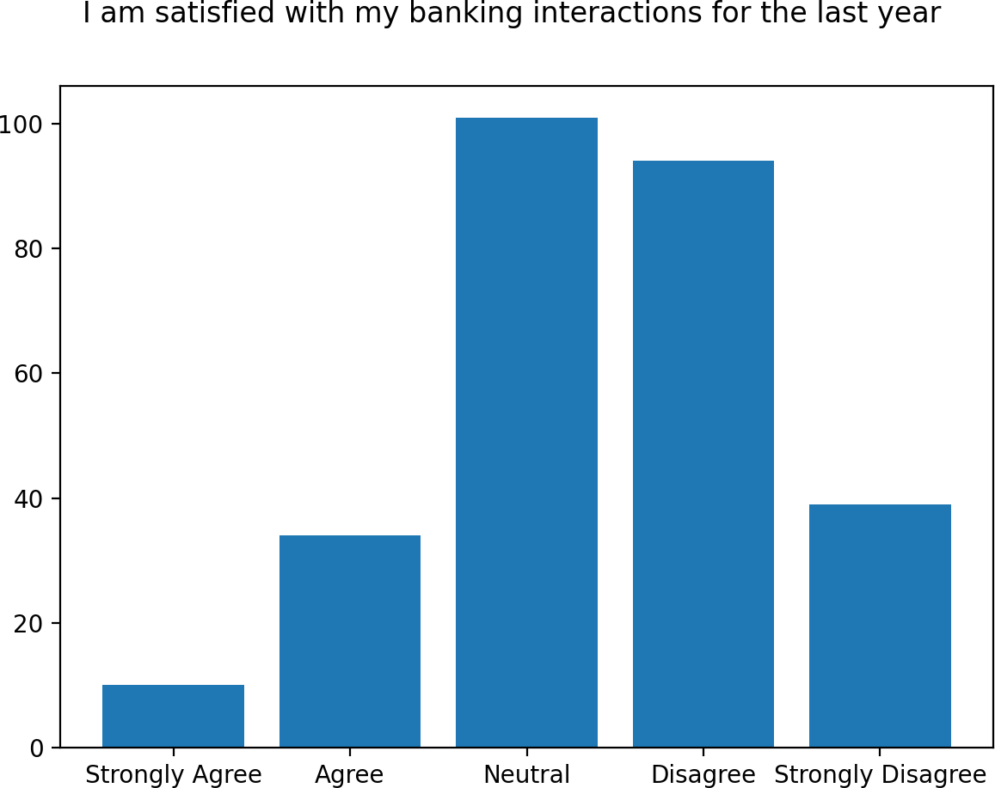

Pic. 7. Satisfaction with banking interaction

*Source:* Own study.

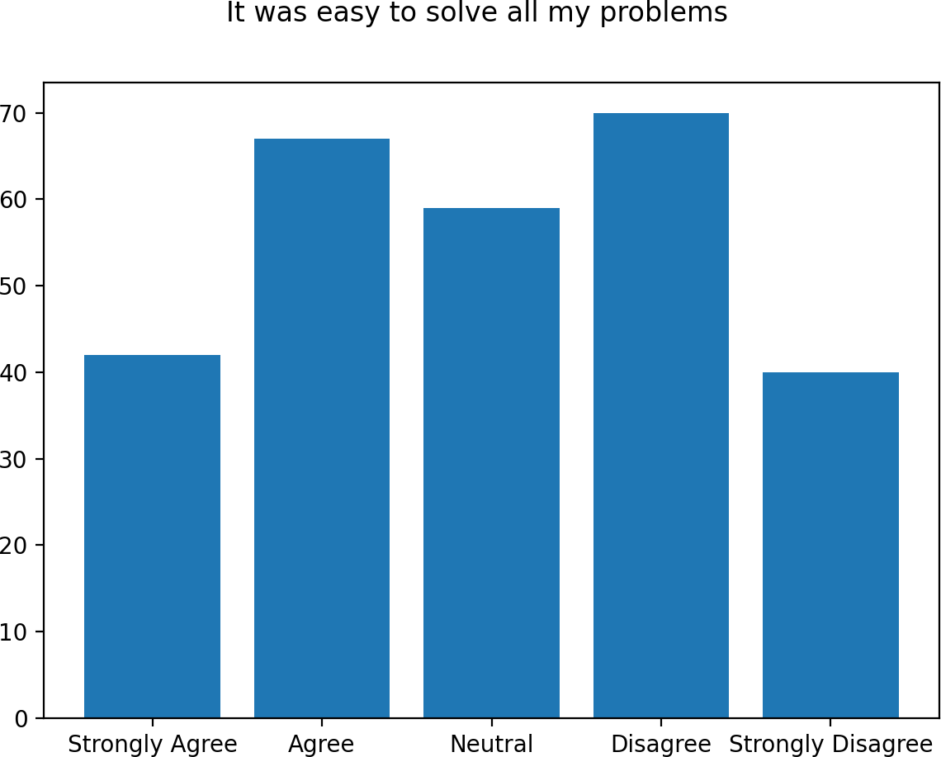

Pic. 8. Satisfaction with problem-solving

*Source:* Own study.

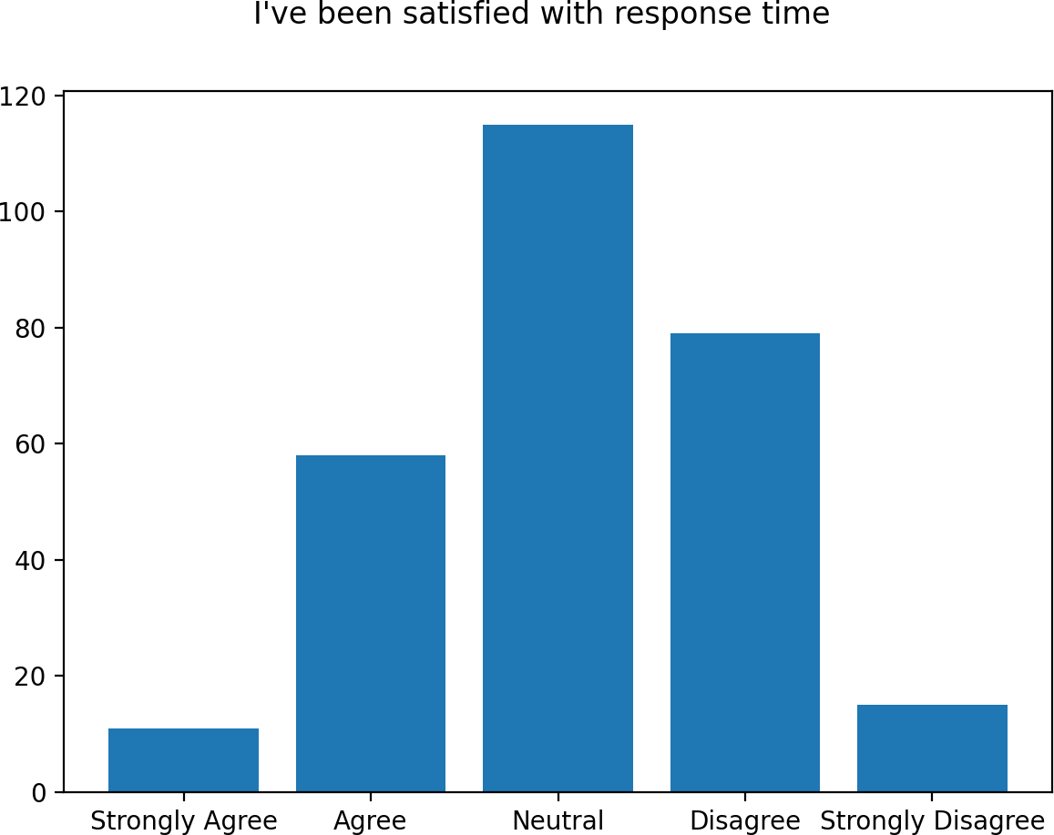

Pic. 9. Satisfaction with response time

*Source:* Own study.

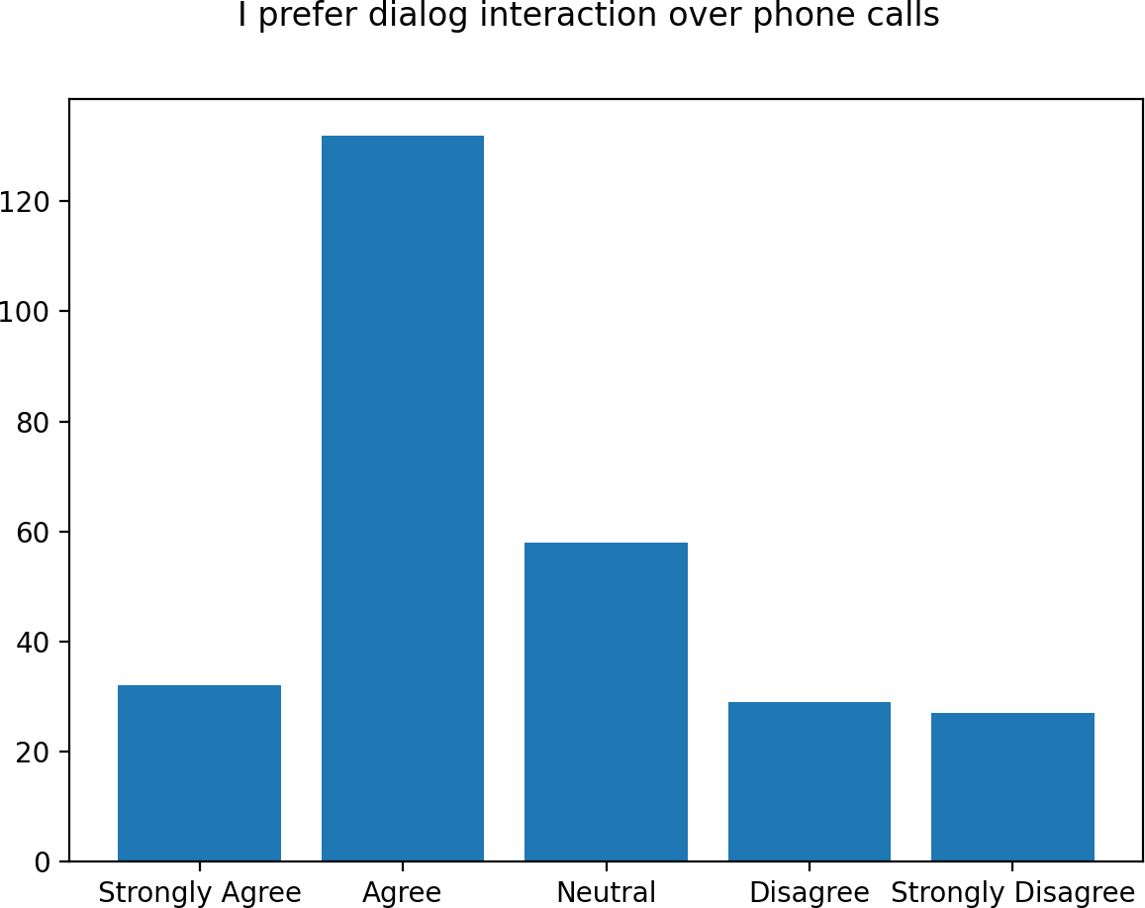

Pic. 10. Preferences between dialogs and calls

*Source:* Own study.

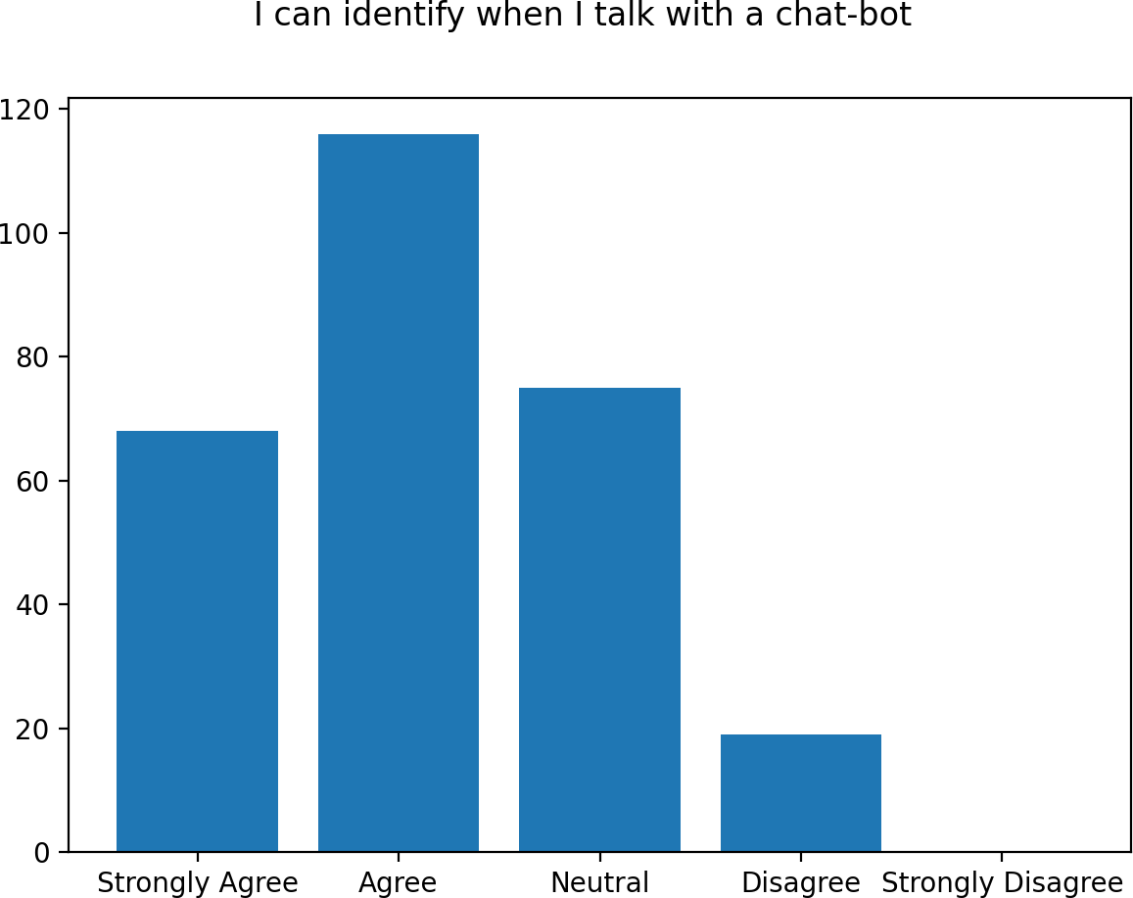

Pic. 11. Chat-bot awareness

*Source:* Own study.

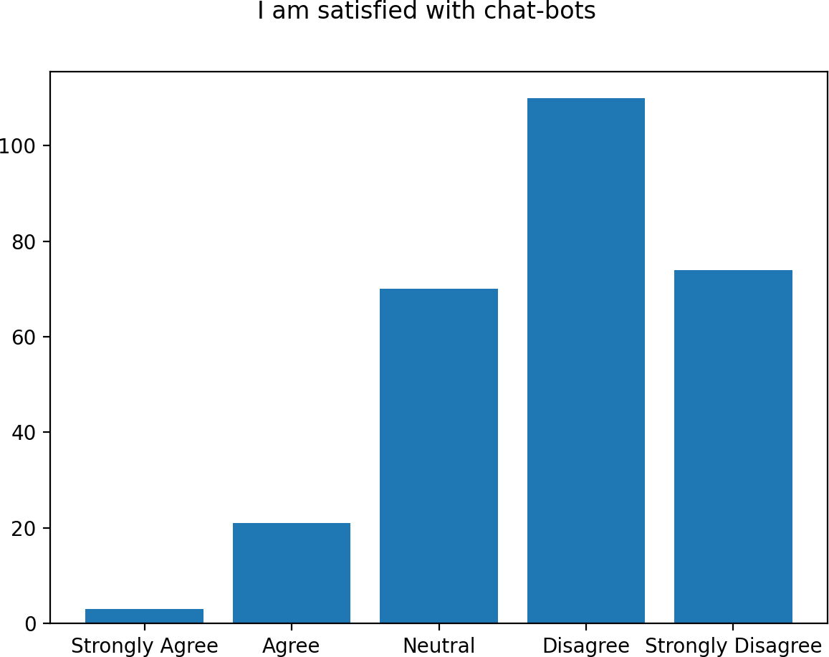

Pic. 12. Satisfaction with chat-bot

*Source:* Own study.

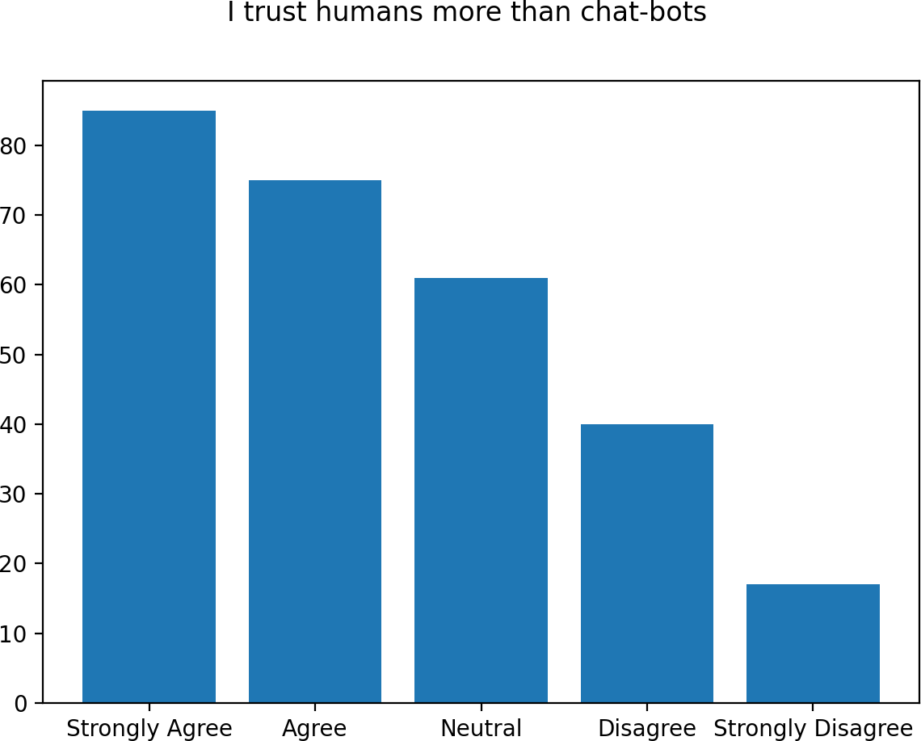

Pic. 13. Client trust towards interlocutor

*Source:* Own study.

is a perfect negative correlation between questions about chat-bot awareness and satisfaction with chat-bots.

Additionally, we can observe higher trust to human employees over automated solutions. As a result, survey showed a lot of interesting points and formed multiple conclusions. In general, survey showed that people between 18 and 32 years old prefer dialog interfaces over vocal communication. Moreover, clients will prefer dialog forms over other forms even though those are not as effective as clients expect and may result in slightly negative experience for client. On the opposite, common argument of long response time may be outdated, as even

more demanding generation of clients are neutral.

Although, dialogs are preferred, clients tend to trust people more. In my opinion, this opin-

ion is very subjective, as automated solutions may advise more exactly and don’t require prior experience. Probably, this is connected to high dissatisfaction with existing chat-bots effective- ness. Moreover, negative impact of chat-bots forced clients to learn to determine when they talk to a chat-bot and when to an employee. This results in a strong client association that chat-bots are bad and effective.

Consequently, next generation of chat-bots have to speak to clients in a natural language, in order to be indistinguishable from employee. Thus, Artificial Intelligence technologies, in- cluding Machine Learning and Natural Language Programming are highly required.

Nevertheless, we can observe general minor satisfaction with existing form of user in- teraction and negative expectations about automated solutions. This shows that clients are not ready for chat-bots yet. Moreover, it is possible to conclude that chat-bots are not that much for consumers, as they are an important evolution milestone for the banks.

Even if there would be a chat-bot solution which passes some limited version of Turing test, when the customer finds out that all that he was talking to a chat-bot, he may feel deceived and lost trust to a bank.

The main hypothesis of this thesis was that Commercial Banking clients are ready for Automated Front Offices in a form of Chat-bot with Artificial Intelligence and will positevely react to its injection into banking infrastracture. Conclusively, this hypothesis has to be rejected. People are not ready and have negative subjective feelings towards chat-bots. Changing those feelings would require significant marketing costs.

However, the most valid injection of a chat-bot solution would be in a hybrid approach. Hybrid approach is a synergy between human employee and an automated chat-bot system. In hybrid approach robot recommends an answer to an operator based on existing knowledge base. In this case, customer trusts and employee, but receives exact fast answer from an internal chat- bot system.

# CONCLUSIONS

The main trend in commercial banking for the last decade is openness and availability. Even though, from a regulatory perspective, forcing banks to allow third-party services to oper- ate with a bank in a digital way is a form to divide natural monopolies, openness and availabil- ity is highly important on banking market by themselves. The market of information systems, services and technologies is in all-time high and, obviously, affects such a giant as a banking market. Banks by its structure are stable and fundamental, which is a logical barrier against extensive development and changes. Nevertheless, an exponential growth of digital fields is a catalyst for evolution of a banking market.

Nowadays, commercial banks do both front-office and back-office work. Famous banking stability and guarantees are good for back-office, but can be a massive hurdle in a front-office. Front-office, as a form of client interaction, has to change as fast as possible in order to achieve its client, client’s needs and purposes. Especially, when entire human ecosystem creates new forms of people communication and interaction. Extrapolating last two decades we can expect future development of both banking openness and world digitalization. Accordingly, banks have to adapt to those changes.

Currently, two trends, two forms of bank evolution are formulating — Bank-as-a-Service and Bank-as-a-Platform. Bank-as-a-Service in a final form makes from a bank a back-office only construct, whose customers are various financial services, which can be risky, can experiment and are not too big to fall. Although, this form reminds of factoring, it is not. In spite, those third-party financial services can create their own front-offices, and can operate in fields, which are not available to common bank, in a such way that clients even don’t know in which banks their accounts and loans are. Bank-as-a-Platform, oppositely, is a center, which unites other third-party financial services under its hood and brandname.

The main subject of this study was to research current state of industry, regulations and technology in order to examine requirements for a Chat-bot solution with Artificial Intelligence in a Com mercial Banking Front Office and usefulness of such solution in a current market state.

The main hypothesis was: Commercial Banking clients are ready for Automated Front Offices in a form of Chat-bot. To proof this thesis the research survey was conducted. The result prove that the hypothesis is …………………

Therefore, due to technology development, digitalizaton banks need new forms of inter- action. Moreover, younger generation is known to be more textual, messenger-friendly, and often voice interaction impacts negatively. Among possibilities, one of the most efficient is a chat-bot. From customer perspective chat-bot allows solving problems without spending time on waiting for a customer service and without repeating same question towards multiple con- sultants. From the banking side, more simple chat-bots decrease costs on customer service and open the possibility to transfer hired employees into less digital fields that require specialization. Furthermore, the same instrument may significantly increase client engagement and offer growth mechanisms. On the other hand, in order to achieve client engagement and use mentioned growth mechanisms, bank has to take a massive amount of risk and costs.

Regardless, banking sector should use openness trend and entire digital evolution in order to be in the market. Moving towards Open Banking helps banking to share work and risks in client interaction. Consequently, mentioned Machine Learning based chat-bots can be done entirely by third-party providers and supported by them, if there are proper instruments done by bank that allows those to use. On the other side, third-party providers may not be able to do it entirely, but can offer certain blocks of logic. In this case, a bank has to build a chat-bot and invest, but with the help of third-party partners. For a bank mentioned system would be a beautiful piece of a technology, a state-of-art, even though it will require lots of investments and time.

In my opinion, division of labour in banking sector is inevitable. Unfortunately, it is impossible to know which way would banks develop, towards Banks-as-a-Platform or towards Banks-as-a-Service.

In both options banks have to make actions towards smart textual forms of client commu- nication. The point is to develop solution iteratively. Firstly, in all cases banks have to move to even Opener Banking and create even more extensive API. After that, banks can choose which way do they want to go, either to use already existing solution and integrate with their systems, or to create something entirely new with the latest technologies available. Integrating existing, more simple rule-based solutions without Artificial Intelligence is an efficient form of interac- tion due to the fact that entire chat-bot industry is still emerging. On the other side, creating own Chat-bot with Artifical Intelligence, Machine Learning and Natural Language Processing is an insecure choice, possible for large banks, but definitely extremelly dangerous for small- and medium-sized banks. Therefore, building chat-bots via third-party development companies as solutions on premise would be the most balanced way of development of this interaction.

# BIBLIOGRAPHY

Brett King. Bank 4.0. Banking Everywhere, Never at a Bank. John Wiley & Sons Ltd. 2019. Kimberly Mlitz. Big data and business analytics revenue worldwide 2015-2022. Statista, August

2021. On line. Date of Access: September 30th 2021. <https://www.statista.com/statistics/551501/worldwide-big-data-business-analytics-revenue/>

Bolanowski W.. Digital Banking: Way to 2020 and a Look into the Future. European Financial Congress, 2020. On line. Date of Access: September 30th 2021.

[https://www.efcongress.com/wp-content/uploads/2020/10/Wyzwania-informatyki-bankowej.](https://www.efcongress.com/wp-content/uploads/2020/10/Wyzwania-informatyki-bankowej.pdf) [pdf](https://www.efcongress.com/wp-content/uploads/2020/10/Wyzwania-informatyki-bankowej.pdf)

Tunde Olanrewaju. The rise of the digital bank. McKinsey, July 2014. On line. Date of Access: September 30th 2021.

[https://www.mckinsey.com/business-functions/mckinsey-digital/our-insights/the-rise-of-the-](https://www.mckinsey.com/business-functions/mckinsey-digital/our-insights/the-rise-of-the-digital-bank) [digital-bank](https://www.mckinsey.com/business-functions/mckinsey-digital/our-insights/the-rise-of-the-digital-bank)

Deloitte. Digital Banking Maturity 2020. Deloitte, 2020. On line. Date of Access: September 30th 2021.

[https://www2.deloitte.com/content/dam/Deloitte/lu/Documents/financial-services/Banking/lu-](https://www2.deloitte.com/content/dam/Deloitte/lu/Documents/financial-services/Banking/lu-digital-banking-maturity-2020.pdf) [digital-banking-maturity-2020.pdf](https://www2.deloitte.com/content/dam/Deloitte/lu/Documents/financial-services/Banking/lu-digital-banking-maturity-2020.pdf)

Gaurav Sharma. What is Digital Banking?. VentureSkies, April 2017. On line. Date of Access: September 30th 2021.

<https://www.ventureskies.com/blog/digital-banking>

Sam Van Horebeek, Annie Chan. Virtual Banking and Open Banking. Comparing digital dis- tupting across the world. Wavestone, 2020. On line. Date of Access: September 30th 2021.

<https://www.wavestone.com/app/uploads/2018/12/Virtual-banking.pdf>

European Parliament. Payment Service Directive. Official Journal of the European Union , 2007.

On line. Date of Access: September 30th 2021.

[https://eur-lex.europa.eu/legal-content/PL/TXT/PDF/?uri=CELEX:32007L0064&from=en](https://eur-lex.europa.eu/legal-content/PL/TXT/PDF/?uri=CELEX%3A32007L0064&from=en)

European Parliament. Payment Service Directive. Official Journal of the European Union, 2015.

On line. Date of Access: September 30th 2021.

[https://eur-lex.europa.eu/legal-content/EN/TXT/PDF/?uri=CELEX:32015L2366&from=EN](https://eur-lex.europa.eu/legal-content/EN/TXT/PDF/?uri=CELEX%3A32015L2366&from=EN)

Alasdair Smith. Retail banking market investigation. Competition and Markets Authority, Au- gust 2016. On line. Date of Access: September 30th 2021.

[https://assets.publishing.service.gov.uk/media/57ac9667e5274a0f6c00007a/retail-banking-m](https://assets.publishing.service.gov.uk/media/57ac9667e5274a0f6c00007a/retail-banking-market-investigation-full-final-report.pdf) [arket-investigation-full-final-report.pdf](https://assets.publishing.service.gov.uk/media/57ac9667e5274a0f6c00007a/retail-banking-market-investigation-full-final-report.pdf)

Deloitte. How to flourish in an uncertain future. Open banking and PSD2. Deloitte, 2018. On line. Date of Access: September 30th 2021.

[https://www2.deloitte.com/content/dam/Deloitte/cz/Documents/financial-services/cz-open-b](https://www2.deloitte.com/content/dam/Deloitte/cz/Documents/financial-services/cz-open-banking-and-psd2.pdf) [anking-and-psd2.pdf](https://www2.deloitte.com/content/dam/Deloitte/cz/Documents/financial-services/cz-open-banking-and-psd2.pdf)

OBIE. Open Banking Implementation Entity. OBIE, 2020. On line. Date of Access: September 30th 2021.

<https://www.openbanking.org.uk/about-us/>

European Banking Authority. Final guidelines on the security of internet payments. European Banking Authority, December 2014. On line. Date of Access: September 30th 2021.

[https://www.eba.europa.eu/regulation-and-policy/consumer-protection-and-financial-innovati](https://www.eba.europa.eu/regulation-and-policy/consumer-protection-and-financial-innovation/guidelines-on-internet-payments-security) [on/guidelines-on-internet-payments-security](https://www.eba.europa.eu/regulation-and-policy/consumer-protection-and-financial-innovation/guidelines-on-internet-payments-security)

Philip Boucher. Artificial intelligence: How does it work, why does it matter, and what can we do about it?. European Parliamentary Research Service, June 2020. On line. Date of Access: September 30th 2021.

[https://www.europarl.europa.eu/RegData/etudes/STUD/2020/641547/EPRS_STU(2020)641](https://www.europarl.europa.eu/RegData/etudes/STUD/2020/641547/EPRS_STU(2020)641547_EN.pdf) [547_EN.pdf](https://www.europarl.europa.eu/RegData/etudes/STUD/2020/641547/EPRS_STU(2020)641547_EN.pdf)

Gil Press. A Very Short History Of Big Data. Forbes, May 2013. On line. Date of Access: September 30th 2021.

<https://www.forbes.com/sites/gilpress/2013/05/09/a-very-short-history-of-big-data/>

Andrea De Mauro, Marco Greco, Michele Grimaldi. What is Big Data? A Consensual Definition and a Review of Key Research Topics. University of Sheffield, 2015. On line. Date of Access: September 30th 2021.

<https://www.dhi.ac.uk/san/waysofbeing/data/data-crone-demauro-2015.pdf>

Michael Chui, Vishnu Kamalnath, Brian McCarthy. An executive’s guide to AI. McKinsey & Company, 2020. On line. Date of Access: September 30th 2021.

[https://www.mckinsey.com/business-functions/mckinsey-analytics/our-insights/an-executive](https://www.mckinsey.com/business-functions/mckinsey-analytics/our-insights/an-executives-guide-to-ai) [s-guide-to-ai](https://www.mckinsey.com/business-functions/mckinsey-analytics/our-insights/an-executives-guide-to-ai)

Olivia Oran. Wall Street hopes artificial intelligence software helps it hire loyal bankers. Reuters, June 2016. On line. Date of Access: September 30th 2021.

<https://www.reuters.com/article/us-banks-hiring-ai-idUSKCN0YT163>

Koji Okuda. Japan’s megabanks to automate around 30,000 jobs’ worth of work. Nikkei Asia, October 2017. On line. Date of Access: September 30th 2021.

[https://asia.nikkei.com/Economy/Japan-s-megabanks-to-automate-around-30-000-jobs-worth](https://asia.nikkei.com/Economy/Japan-s-megabanks-to-automate-around-30-000-jobs-worth-of-work2)

[-of-work2](https://asia.nikkei.com/Economy/Japan-s-megabanks-to-automate-around-30-000-jobs-worth-of-work2)

Mitsubishi UFJ Financial Group Inc.. Digital Strategy. Mitsubishi UFJ Financial Group Inc., February 2019. On line. Date of Access: September 30th 2021.

<https://www.mufg.jp/dam/ir/presentation/2018/pdf/slides190219_en.pdf>

Jim Marous. AI Could Destroy Traditional Banking As We Know It. The Financial Brand, Au- gust 2018. On line. Date of Access: September 30th 2021.

[https://thefinancialbrand.com/74626/ai-transform-disrupt-banking-financial-wef-trends-anal](https://thefinancialbrand.com/74626/ai-transform-disrupt-banking-financial-wef-trends-analysis/) [ysis/](https://thefinancialbrand.com/74626/ai-transform-disrupt-banking-financial-wef-trends-analysis/)

Laura Noonan. AI in Banking: the Reality Behind the Hype. The Financial Times, April 2018.

On line. Date of Access: September 30th 2021. <https://www.ft.com/content/b497a134-2d21-11e8-a34a-7e7563b0b0f4>

Thomas Smale. 5 Ways Artificial Intelligence Already Transforming the Banking Industry. En- trepreneur, September 2018. On line. Date of Access: September 30th 2021.

<https://www.entrepreneur.com/article/319921>

Pericles Anetos. Banking on the Artificial Intelligence revolution. The Banking Association South Africa, August 2018. On line. Date of Access: September 30th 2021.

[https://www.businesslive.co.za/bt/business-and-economy/2018-08-25-banking-on-the-artific](https://www.businesslive.co.za/bt/business-and-economy/2018-08-25-banking-on-the-artificial-intelligence-revolution/) [ial-intelligence-revolution/](https://www.businesslive.co.za/bt/business-and-economy/2018-08-25-banking-on-the-artificial-intelligence-revolution/)

Lisa Joyce. Artificial Intelligence and the Banking Industry’s $1 Trillion Opportunity. The Fi- nancial Brand, May 2018. On line. Date of Access: September 30th 2021.

<https://thefinancialbrand.com/72653/artificial-intelligence-trends-banking-industry/>

Roy Soumik. Bank of America to use AI for currency research. T_HQ, July 2018. On line. Date of Access: September 30th 2021.

<https://techhq.com/2018/07/bank-of-america-to-use-ai-for-currency-research/>

Wells Fargo. Engaging tech for your business. Using Artificial Intelligence to connect with cus- tomers. Wells Fargo, 2020. On line. Date of Access: September 30th 2021.

[https://www.wellsfargo.com/biz/wells-fargo-works/planning-operations/planning-marketing/](https://www.wellsfargo.com/biz/wells-fargo-works/planning-operations/planning-marketing/engaging-tech-for-your-business/) [engaging-tech-for-your-business/](https://www.wellsfargo.com/biz/wells-fargo-works/planning-operations/planning-marketing/engaging-tech-for-your-business/)

Sarah Butcher. JPMorgan’s enormous AI hiring push. EFinancial Careers, March 2021. On line.

Date of Access: September 30th 2021. <https://www.efinancialcareers.com/news/2021/03/jpmorgan-artificial-intelligence>

Beena Ammanath, Susanne Hupfer, David Jarvis. Thriving in the era of pervasive AI. Deloitte, August 2019. On line. Date of Access: September 30th 2021.

[https://www2.deloitte.com/content/dam/Deloitte/cn/Documents/about-deloitte/deloitte-cn-dtt](https://www2.deloitte.com/content/dam/Deloitte/cn/Documents/about-deloitte/deloitte-cn-dtt-thriving-in-the-era-of-persuasive-ai-en-200819.pdf)

[-thriving-in-the-era-of-persuasive-ai-en-200819.pdf](https://www2.deloitte.com/content/dam/Deloitte/cn/Documents/about-deloitte/deloitte-cn-dtt-thriving-in-the-era-of-persuasive-ai-en-200819.pdf)

IHS Markit. Artificial Intelligence in Banking Report. IHS Markit, April 2019. On line. Date of Access: September 30th 2021.

[https://news.ihsmarkit.com/prviewer/release_only/slug/technology-global-business-value-arti](https://news.ihsmarkit.com/prviewer/release_only/slug/technology-global-business-value-artificial-intelligence-banking-reach-300-billion-203) [ficial-intelligence-banking-reach-300-billion-203](https://news.ihsmarkit.com/prviewer/release_only/slug/technology-global-business-value-artificial-intelligence-banking-reach-300-billion-203)

Roy Jubraj, Tom Graham, Eve Ryan. Redefine Banking with Artificial Intelligence. Accenture, 2018. On line. Date of Access: September 30th 2021.

[https://www.accenture.com/t00010101t000000z w /gb-en/_acnmedia/pdf-71/accenture-b](https://www.accenture.com/t00010101t000000z__w__/gb-en/_acnmedia/pdf-71/accenture-banking-aw-jf-web.pdf) [anking-aw-jf-web.pdf](https://www.accenture.com/t00010101t000000z__w__/gb-en/_acnmedia/pdf-71/accenture-banking-aw-jf-web.pdf)

Refinitiv. The Future of Trading Technology in 2024. Refinitiv, 2019. On line. Date of Access: September 30th 2021.

[https://www.refinitiv.com/content/dam/marketing/en_us/documents/reports/future-of-trading-](https://www.refinitiv.com/content/dam/marketing/en_us/documents/reports/future-of-trading-technology-in-2024.pdf) [technology-in-2024.pdf](https://www.refinitiv.com/content/dam/marketing/en_us/documents/reports/future-of-trading-technology-in-2024.pdf)

Deluxe. Remittance Intelligent Matching. Deluxe, 2021. On line. Date of Access: September 30th 2021.

<https://www.deluxe.com/payments/receivables-management/remittance-intelligent-matching/>

Deluxe. As AI gap widens, midsize banks must act now or risk falling behind. Deluxe, February 2020. On line. Date of Access: September 30th 2021.

<https://www.deluxe.com/blog/mid-sized-banks-behind-ai-curve/>

Philipp Maume. Robo-advisors. How do they fit in the existing EU regulatory framework, in particular with regard to investor protection?. Policy Department for Economic, Scientific

and Quality of Life Policies, June 2021. On line. Date of Access: September 30th 2021. [https://www.europarl.europa.eu/RegData/etudes/STUD/2021/662928/IPOL_STU(2021)66292](https://www.europarl.europa.eu/RegData/etudes/STUD/2021/662928/IPOL_STU(2021)662928_EN.pdf)

[8_EN.pdf](https://www.europarl.europa.eu/RegData/etudes/STUD/2021/662928/IPOL_STU(2021)662928_EN.pdf)

Autonomous Research. #Machine Intelligence & Augmented Finance. How Artificial Intelli- gence creates $1 trillion of change in the front, middle and back office of the financial ser- vices industry. Autonomous Research, August 2018. On line. Date of Access: September 30th 2021.

[http://www.smallake.kr/wp-content/uploads/2018/08/AutonomousNEXT_06_MachineIntellig](http://www.smallake.kr/wp-content/uploads/2018/08/AutonomousNEXT_06_MachineIntelligenceAugmentedFinance.pdf) [enceAugmentedFinance.pdf](http://www.smallake.kr/wp-content/uploads/2018/08/AutonomousNEXT_06_MachineIntelligenceAugmentedFinance.pdf)

Sonali Kulkarni, Pranav Arora. Ready for Conversational Banking?. Accenture, 2019. On line.

Date of Access: September 30th 2021.

[https://www.accenture.com/_acnmedia/pdf-102/accenture-ready-for-conversational-banking.p](https://www.accenture.com/_acnmedia/pdf-102/accenture-ready-for-conversational-banking.pdf) [df](https://www.accenture.com/_acnmedia/pdf-102/accenture-ready-for-conversational-banking.pdf)

Humley. Consumer Online Banking Trends. Humley, 2018. On line. Date of Access: September 30th 2021.

[https://gallery.mailchimp.com/6876a5198dfef32603ce8474d/files/aa26e0e2-dc8e-47d5-8952-](https://gallery.mailchimp.com/6876a5198dfef32603ce8474d/files/aa26e0e2-dc8e-47d5-8952-6766332cef53/Online_Banking_Report_v2.pdf) [6766332cef53/Online_Banking_Report_v2.pdf](https://gallery.mailchimp.com/6876a5198dfef32603ce8474d/files/aa26e0e2-dc8e-47d5-8952-6766332cef53/Online_Banking_Report_v2.pdf)

Accenture. Chatbots are here to stay. Accenture, 2018. On line. Date of Access: September 30th 2021.

[https://www.accenture.com/_acnmedia/pdf-77/accenture-research-conversational-ai-platform](https://www.accenture.com/_acnmedia/pdf-77/accenture-research-conversational-ai-platforms.pdf) [s.pdf](https://www.accenture.com/_acnmedia/pdf-77/accenture-research-conversational-ai-platforms.pdf)

Nicola Anzivino, Paolo Anfossi, Dario Saracino. Artificial Intelligence Evolution — main trends. PriceWaterCoopers, 2020. On line. Date of Access: September 30th 2021.

<https://www.pwc.com/it/it/publications/assets/docs/pwc-ai-evolution-financial-services.pdf>

Ifbyphone, Inc.. Consumers Waiting On-Hold More Than One Minute Won’t Convert or Refer.

Ifbyphone, Inc., 2012. On line. Date of Access: September 30th 2021. [http://www.dialogtech.com/wp-content/uploads/2012/05/Ifbyphone-Consumer-Response-surv](http://www.dialogtech.com/wp-content/uploads/2012/05/Ifbyphone-Consumer-Response-survey-May-2012.pdf)

[ey-May-2012.pdf](http://www.dialogtech.com/wp-content/uploads/2012/05/Ifbyphone-Consumer-Response-survey-May-2012.pdf)

Statista Research Department. Number of monthly active Facebook users worldwide as of 2nd quarter 2021. Statista, 2021. On line. Date of Access: September 30th 2021.

[https://www.statista.com/statistics/264810/number-of-monthly-active-facebook-users-world](https://www.statista.com/statistics/264810/number-of-monthly-active-facebook-users-worldwide/) [wide/](https://www.statista.com/statistics/264810/number-of-monthly-active-facebook-users-worldwide/)

Heather Pemberton Levy. Gartner Predicts a Virtual World of Exponential Change. Gartner, October 2016. On line. Date of Access: September 30th 2021.

[https://www.gartner.com/smarterwithgartner/gartner-predicts-a-virtual-world-of-exponential](https://www.gartner.com/smarterwithgartner/gartner-predicts-a-virtual-world-of-exponential-change/)

[-change/](https://www.gartner.com/smarterwithgartner/gartner-predicts-a-virtual-world-of-exponential-change/)

Wojciech Bolanowski. Open Banking Ecosystem in Testing Mode. Salt Edge Inc., 2020. On line. Date of Access: September 30th 2021.

<https://www.saltedge.com/report_api_integration.pdf>

Adam Scott, Valeria Gallo. European PSD2 Survey Results highlights. Deloitte, October 2017.

On line. Date of Access: September 30th 2021. [https://www2.deloitte.com/content/dam/Deloitte/nl/Documents/financial-services/deloitte-nl-f](https://www2.deloitte.com/content/dam/Deloitte/nl/Documents/financial-services/deloitte-nl-fsi-psd2-survey-results-highlights.pdf)

[si-psd2-survey-results-highlights.pdf](https://www2.deloitte.com/content/dam/Deloitte/nl/Documents/financial-services/deloitte-nl-fsi-psd2-survey-results-highlights.pdf)

# LIST OF APPENDICES

## List of shorts

AI - Artificial Intelligence

ML - Machine Learning

NLP - Natural Language Programming NLU - Natural Language Understanding NLG - Natural Language Generation GDPR - General Data Protection Regulation EBA - European Banking Authority

CMA - Competition and Markets Authority OBIE - Open Banking Implementation Entity PSD - Payment Service Directive, first edition

PSD2 - Payment Service Directive, second edition ASPSP - Account Servicing Payment Service Provider TPP - Third-Party Provider

AISP - Account Information Service Provider PISP - Payment Initiation Service Provider

PIISP - Payment Instrument Issuer Service Provider SCA - Strong Customer Authentication

PSU - Payment Service User

DBMS - Database Management System MBMS - Model Base Management System CV - Curriculum Vitae

MiFID II - Markets in Financial Instruments Directive, second edition R&D - Research and Development

KYC - Know Your Customer

AML - Anti-Money Laundering

API - Application Programming Interface BaaS - Banking-as-a-Service

BaaP - Banking-as-a-Platform

CRM - Customer Relationship Management

**List of tables**

|  |  |  |
| --- | --- | --- |
| Table 1. | Structure of human interaction on banking layers . . . . . . . . . . . . . . . | 9 |
| Table 2. | Scheme of interconnection between PSD2 agents . . . . . . . . . . . . . . . | 17 |
| Table 3. | Consumer preferences for addressing issues . . . . . . . . . . . . . . . . . | 37 |
| Table 4. | Customer Satisfaction Rate by form of Live Chat . . . . . . . . . . . . . . . | 40 |
| Table 5. | Fintech AI Use-cases . . . . . . . . . . . . . . . . . . . . . . . . . . . . . | 41 |
| Table 6. | Chat-bot solutions with NLP AI . . . . . . . . . . . . . . . . . . . . . . . . | 47 |
| Table 7. | Forms of user interaction by type . . . . . . . . . . . . . . . . . . . . . . . | 49 |
| Table 8. | Current route of a user request to a bank . . . . . . . . . . . . . . . . . . . | 53 |
| Table 9. | Open Banking User Request Route . . . . . . . . . . . . . . . . . . . . . . | 54 |
| Table 10. | Open Banking User Request Route with Conversational Banking . . . . . . | 55 |
| Table 11. | User Request Route with Rule-based middleware . . . . . . . . . . . . . . . | 55 |
| Table 12. | Open Banking User Request Route with ML&AI Conversational Banking . | 56 |
| Table 13. | Structure of an integrated chat-bot solution . . . . . . . . . . . . . . . . . . | 56 |
| Table 14. | Structure of a ML&AI Chat-bot solution with Natural Language Processing | 58 |
| Table 15. | Plan of integration of a ML&AI Recommendation and Notification systems | 59 |
| Table 16. | Average costs of PSD2 implementation . . . . . . . . . . . . . . . . . . . . | 59 |
| Table 17. | Expected costs of an Open Banking API implementation . . . . . . . . . . . | 60 |
| Table 18. | Expected costs of a Rule-based middleware solution . . . . . . . . . . . . . | 60 |
| Table 19. | Expected costs of a ML&AI middleware solution . . . . . . . . . . . . . . | 60 |
| Table 20. | Expected costs of ML&AI-based Recommendation and Notification solution | 61 |
| Table 21. | Expected costs of an AI NLP Chat-bot solution with Recommendations . . . | 61 |

**List of Figures**

|  |  |  |
| --- | --- | --- |
| Pic. 1. | % of individuals who used internet banking . . . . . . . . . . . . . . . . . . | 34 |
| Pic. 2. | Distribution of worldwide search traffic . . . . . . . . . . . . . . . . . . . . | 35 |
| Pic. 3. | Number of parameters in NLP AI algorithms . . . . . . . . . . . . . . . . . | 36 |
| Pic. 4. | Frontend of a Bank Assistant chat-bot by Wells Fargo on a Facebook . . . . | 50 |
| Pic. 5. | Ages of respondents . . . . . . . . . . . . . . . . . . . . . . . . . . . . . . | 62 |
| Pic. 6. | Number of banks per respondent . . . . . . . . . . . . . . . . . . . . . . . | 63 |
| Pic. 7. | Satisfaction with banking interaction . . . . . . . . . . . . . . . . . . . . . | 63 |
| Pic. 8. | Satisfaction with problem-solving . . . . . . . . . . . . . . . . . . . . . . . | 64 |

|  |  |  |
| --- | --- | --- |
| Pic. 9. | Satisfaction with response time . . . . . . . . . . . . . . . . . . . . . . . . | 64 |
| Pic. 10. | Preferences between dialogs and calls . . . . . . . . . . . . . . . . . . . . . | 65 |
| Pic. 11. | Chat-bot awareness . . . . . . . . . . . . . . . . . . . . . . . . . . . . . . | 65 |
| Pic. 12. | Satisfaction with chat-bot . . . . . . . . . . . . . . . . . . . . . . . . . . . | 66 |
| Pic. 13. | Client trust towards interlocutor . . . . . . . . . . . . . . . . . . . . . . . . | 66 |

# ANNEXES

## Annex 1. Survey. Satisfaction with Digital Banking Customer Service

1. How old are you? 18-32

33-48

49+

1. How many banks did you interact with for the last year? Number:

Indicate your opinion about each of the following statements.

Strongly

Agree Agree Neutral Disagree

Strongly Disagree

1. I am satisfied with my banking interactions for the last year
2. It was easy to solve all my problems
3. I’ve been satisfied with response time
4. I prefer dialog interaction over phone calls
5. I can identify when I talk with a chat-bot
6. I am satisfied with chat-bots
7. I trust humans more than chat-bots